Table of Contents

Chapter II: CSE System Requirements 3

B. Locate 3

B-1 OBJECTIVE: The system must electronically interface with all appropriate sources to obtain and verify locate, asset and other information on the non-custodial/putative parent or custodial parent. 3

Response B-1-a: 3

Response B-1-a-1: 3

Response B-1-a-2: 3

Response B-1-a-3: 4

Response B-1-a-4: 4

Response B-1-a-5: 4

Response B-1-a-6: 4

Response B-1-a-7: 4

Response B-1-a-8: 4

Response B-1-a-9: 4

Response B-1-a-10: 5

Response B-1-a-11: 5

Response B-1-a-12: 5

Response B-1-a-13: 5

Response B-1-a-14: 5

Response B-1-a-15: 5

Response B-1-a-16: 5

Response B-1-a-17: 6

Response B-1-a-18: 6

Response B-1-a-19: 6

Response B-1-a-20: 6

Response B-1-a-21: 6

Response B-1-b-1: 6

Response B-1-b-2: 7

Response B-1-c-1: 7

Response B-1-c-2: 7

Response B-1-d: 7

Response B-1-e: 8

Response B-1-f: 8

B-2 OBJECTIVE: The system must record, maintain, and track locate activities to ensure compliance with program standards. 9

Response B-2-a-1: 9

Response B-2-a-2: 9

Response B-2-a-3: 9

Response B-2-a-4: 10

Response B-2-a-5: 10

Response B-2-a-6: 10

Response B-2-a-7: 10

Response B-2-b: 10

Response B-2-c-1: 11

Response B-2-c-2: 11

Response B-2-d: 11

B-3 OBJECTIVE: The system must automatically resubmit cases to locate sources. 12

Response B-3-a: 12

Response B-3-b: 12

Response B-3-c: 12

B-4 OBJECTIVE: The system must automatically submit requests for locate to the Federal Parent Locator System (FPLS). 13

Response B-4-1: 13

Response B-4-2: 13

Response B-4-3-a: 13

Response B-4-3-b: 13

Response B-4-b: 14

Response B-4-c-1: 14

Response B-4-c-2: 14

Response B-4-c-3: 14

Response B-4-d: 14

Screen Shots 16

# Chapter II: CSE System Requirements

## B. Locate

### **B-1 OBJECTIVE:** **The system must electronically interface with all appropriate sources to obtain and verify locate, asset and other information on the non-custodial/putative parent or custodial parent.**

Federal Statutory and Regulatory Authority:

42 USC 654 (8) & (9)(B)

42 USC 654A (e) & (f)

45 CFR 303.2(b) and (c)

45 CFR 303.3(b)(1) & (2)

45 CFR 307.10(b)(2), (4)(ii), (9), (13), and (14)

During the weekly Federal Case Registry (FCR) send process all cases are automatically submitted to the Federal Parent Locator Service (FPLS) when no verified address and employer records exist, the non-custodial / putative father Social Security Number (SSN) is not known or a worker requests a locate search by entering an L001 status (Location Investigation Opened) on the case record. These cases are then routed to all Federal agencies as well as the New York State (NYS) Department of Taxation and Finance (DTF), Department of Motor Vehicles (DMV) and Division of Criminal Justice Services (DCJS) to obtain address information.

State System Requirements:

1. The system must have automated interfaces with Federal, State, interstate, and intrastate sources, when appropriate, feasible and cost-effective to facilitate obtaining and verifying case information. Interfaces should include, but not be limited to, the following sources:

##### Response B-1-a:

The locate process is initiated if either respondent SSN is unknown or no verified address or employer records exist. This includes automated interfaces with Federal, State, Interstate and Intrastate sources where appropriate, feasible and cost-effective by automatically sending requests to various sources through automated interfaces to obtain and then accept information.

* 1. Federal Parent Locator System (FPLS)

##### Response B-1-a-1:

The weekly FCR send process submits all locate requests to FPLS and accepts information daily through an automated interface. Disposition reason codes are recorded on the Respondent Location screen (Screen Shot B-1-a-1-i) and reported on the Parent Locator Service report in Worker Alerts (Screen Shot B-1-a-1-ii).

* 1. National Directory of New Hires (NDNH)

##### 

##### Response B-1-a-2:

Information is received and processed daily from the National Directory of New Hires (NDNH) through an automated interface. Disposition reason codes are recorded on the Respondent Location screen (Screen Shot B-1-a-2-i) and reported on the Parent Locator Service report in Worker Alerts (Screen Shot B-1-a-2-ii).

* 1. Federal Case Registry (FCR)

##### Response B-1-a-3:

Case information is submitted to the FCR weekly and accepts information daily through an automated interface. Results are recorded on the Case Information screen (Screen Shot B-1-a-3-i) and reported on the Federal Case Registry report in Worker Alerts (Screen Shot B-1-a-3-ii).

* 1. Department of Motor Vehicles (driver's licenses and vehicle registration)

##### Response B-1-a-4:

Case information is submitted to the DMV weekly and accepts information daily through an automated interface. Disposition reason codes are recorded on the Respondent Location screen (Screen Shot B-1-a-4-i) and reported on the Parent Locator Service report in Worker Alerts (Screen Shot B-1-a-4-ii).

* 1. State Workforce Agency

##### Response B-1-a-5:

Case information is submitted on a monthly basis to the Wage Reporting System (WRS) at DTF as well as the New York State Department of Labor (NYS DOL) through a monthly automated interface. Users also have the ability to request these searches on a daily basis. Disposition reason codes are recorded on the Respondent Information screen (Screen Shot B-1-a 5-i) and reported on the Parent Locator Service report in Worker Alerts (Screen Shot B-1-a-5-ii).

* 1. Department of Natural Resources (fishing and hunting licenses)

##### Response B-1-a-6:

An automated interface with New York State Department of Environmental Conservation (NYS DEC) is conducted semi annually.

* 1. Department of Vital Statistics

##### Response B-1-a-7:

Sending and receiving of information through an automated interface with this source has not been established at this time.

* 1. Department of Corrections

##### Response B-1-a-8:

Case information is submitted to the DCJS weekly and accepts information daily through an automated interface. Disposition reason codes are recorded on the Respondent Location screen (Screen Shot B-1-a-8-i) and reported on the Parent Locator Service report in Worker Alerts (Screen Shot B-1-a-8-ii).

* 1. Credit Bureaus

##### 

##### Response B-1-a-9:

Cases meeting the eligibility criteria are submitted to the four major credit bureaus monthly through an automated interface. However no respondent information is received back from the credit bureaus.

* 1. Postal Service

##### 

##### Response B-1-a-10:

When the respondent address is known, the user can verify the location by generating a Postal Clearance (PCL) on ASSETS. A Postal Clearance (PCL) can be initiated on ASSETS by opening a “V” group on the Status Information screen (Screen Shot B-1-a-10-i) or by selecting the “YES” radio button for “Do you want Postal Clearance Submitted” option while adding a respondent address on Respondent Address screen (Screen Shot B-1-a-10-ii).

* 1. Local/State Tax Administration

##### Response B-1-a-11:

Case information is submitted to DTF weekly and accepts information daily through an automated interface. Disposition reason codes are recorded on the Respondent Location screen (Screen Shot B-1-a-11-i) and reported on the Parent Locator Service report in Worker Alerts (Screen Shot B-1-a-11-ii).

* 1. State IV-A Agency

##### Response B-1-a-12:

Cases in open and pending location status are submitted monthly and receive respondent address information through an automated IV-A to IV-D Interface with the IV-A Agency. (Screen Shot B-1-a-12).

* 1. State IV-E Agency

##### Response B-1-a-13:

IV-E referrals are received manually. If an IV-E worker considers a case to be eligible for IV-D, they forward the referral (DSS-4882) to the IV-D worker manually.

* 1. State Title XIX Agency

##### Response B-1-a-14:

Case information is received on a daily basis from the State Title XIX Agency, through the automated IV-A to IV-D Interface (Screen Shot B-1-a-14).

* 1. State Directory of New Hires

##### Response B-1-a-15:

The New York State Directory of New Hires (SDNH) is located at DTF. Our State Disbursement Unit (SDU) vendor provides the data capture function of new hire information for DTF and sends a daily data file to DTF, who then forwards this information to the NDNH, and the NYS DOL. The new hire information is accepted and processed on matched cases. Users are notified and information is reported on the Parent Locator Service report in Worker Alerts (Screen Shot B-1-a-15).

* 1. State Disbursement Unit (SDU)

##### Response B-1-a-16:

The SDU is the centralized collection and disbursement processing center that receives and process payments and, prints and mails checks. Information received by the SDU is recorded on various screens of the ASSETS application. The most prevalent screen is the Money screen (Screen Shot B-1-a-16).

* 1. Public Utilities

##### Response B-1-a-17:

NYS is currently developing and testing a data exchange with AT&T. ASSETS has a document generation module which allows a local district user to generate an administrative subpoena (Screen Shot B-1-a-17) that is submitted to a public utility to obtain the needed information.

* 1. Financial Institutions

##### Response B-1-a-18:

Information from Financial Institutions is received monthly through an automated interface and reported on the Warnings report in Worker Alerts (Screen Shot B-1-a-18-i) and the Respondent Assets Information screen (Screen Shot B-1-a-18-ii).

* 1. State Licensing Agencies

##### Response B-1-a-19:

Information from the NYS Department of State (DOS), NYS DEC, and DMV is received through an automated interface. The resulting information is reported on the Professional License screen (Screen Shot B-1-a-19).

* 1. State agencies with jurisdiction over real and personal property

##### Response B-1-a-20:

ASSETS submits and accepts information with DTF through an automated interface and the information is used as an enforcement tool on eligible accounts. Respondent address and respondent employer information are also obtained from this source (Screen Shot B-1-a-20).

* 1. Tribal IV-D programs

##### Response B-1-a-21:

Sending and receiving of information through an automated interface with this source is unavailable.

Note: Data required to be furnished to the NDNH by the State under the three components of NDNH (i.e., new hire information, Quarterly Wage and Unemployment Insurance claimant information) need not be submitted by the Statewide automated system. The decision as to which State entity will report this information to the NDNH is determined by the State. However, if data is not reported as required, the Title IV-D agency will be held accountable.

1. If an automated interface cannot be established for a specific source:
2. The system must automatically prepare the documents required to submit the case to the information source.

##### Response B-1-b-1:

Interfaces are automated. If needed, a system-generated request can be made on the ASSETS Status Information screen, Respondent Address screen and the Respondent Employer screen to submit a case to information sources not available through the regularly scheduled automated interface. Opening a “V” (Postal verification) or “F” (Employment and Wage clearances) group on the Status Information screen (**Screen Shot B-1-b-1-i)** will automatically generate the Postal Clearance(PCL) or Wage Health Benefit Report (WHBR). Also, by selecting the “Yes” radio button on the Respondent Address Details screen for “Do you want Postal Clearance Submitted” (**Screen Shot B-1-b-1-ii**) or selecting the “Yes” radio button for “Wage Health and Benefit Report to be sent to the employer” on Respondent Employer Detail Edit Page (**Screen Shot B-1-b-1-iii**) will automatically generate a PCL or WHBR document (respectively).

and

1. The system must provide an easily accessible means to enter into the automated case record all manual attempts to obtain information and the results.

##### Response B-1-b-2:

A manual request can be made on the ASSETS Status Information screen (Screen Shot B-1-b-2-i) to obtain information from a source by opening a “F” or “V” group. Results of the returned documents are reported on the Daily Status Changes report in Worker Alerts (Screen Shot B-1-b-2-ii).

1. The system must automatically follow up when information is solicited and no response is received within a reasonable amount of time, based on State experience. The system must:
2. Re-access the source using an automated interface, if available,

##### Response B-1-c-1:

Follow-up with all sources on cases with pending location identified by the L100 status on the Status Information screen (Screen Shot B-1-C-1) is automated. All sources are re-accessed as necessary through automated interfaces every 75 days.

or

1. If an automated interface is not available, notify the caseworker and automatically generate the documents necessary to encourage a response.

##### Response B-1-c-2:

All interfaces are automated. Information received from automated locate source is reported on the Parent Locator Service report in Worker Alerts (Screen Shot B-1-c-2-i) to the specific worker whose worker code appears on the Respondent Information screen (Screen Shot B-1-c-2-ii). The user will then generate the necessary verification documents, i.e., a PCL by opening a “V” group or a WHBR by opening a “F” group on the Status Information screen (Screen Shot B-1-c-2-iii).

1. The system must accept unsolicited locate information from the FPLS as proactive matches occur between State participants registered through the FCR and as State FCR participants are matched to New Hire, Quarterly Wage and Unemployment Insurance claim records on the National Directory of New Hire.

##### Response B-1-d:

Unsolicited information is accepted from the FPLS. Information received from FPLS is recorded on the Respondent Location screen (Screen Shot B-1-d-i) and any exceptions are recorded on the Respondent Employer screen. New Hire, Quarterly Wage and Unemployment information are recorded on the Respondent Employer screen (Screen Shot B-1-d-ii).

1. At a minimum, the system must make data received electronically through any of the interfaces listed under paragraph (a) above available online to the caseworker along with the capability to electronically record in the case record any data received through an interface.

##### Response B-1-e:

All data received electronically through any of the interfaces listed in paragraph (a) are stored in the case record.

1. Optional: Even if the State has an automated interface, there is benefit to being able to also submit a manual locate request to several sources.

##### Response B-1-f:

Users in local districts have the capability to manually submit a locate request by opening an L001 status on the Status Information screen (Screen Shot B-1-f).

Recommended Data Elements: The CSE Data Standards Registry is operational and includes over 1,000 principle data elements. The data standards registry contains data elements that are exchanged between CSE partners, their definition, name and other defining attributes. This link <http://www.acf.hhs.gov/cse/dsr/> takes you to the Registry. Clicking on Community/Guest Users on the Welcome page and then clicking on Info will give you access to the User’s Guide on how to access and use the CSE Data Standards Registry. A user can search for data elements by definition (with references), name, and format, and relevant business rules. The search facility will also return data elements that are identical or similar and will list the data exchanges where they are used.

For New Hire – This link provides information on the Guide for Data Submission from State New Hire Directories to National Directory of New Hire:  
<http://www.acf.hhs.gov/programs/cse/newhire/ndnh/ndnh.htm>

**Best Practices**

For FPLS **-** This link is to Tips, Techniques and Technology for using FPLS data and a web-based training course is organized into modules with lessons that include: ‘ABC's of the Locate Function,’ ‘State and Parent Locator Services’, and ‘Putting It All Together’:   
<http://www.acf.hhs.gov/programs/cse/newhire/library/training/training.htm>

This link provides information on the National Directory of New Hires:  
<http://www.acf.hhs.gov/programs/cse/newhire/ndnh/ndnh.htm>

This link is to a presentation by the Commonwealth of Pennsylvania on its filter to reduce duplicate and older addresses: <http://www.acf.hhs.gov/programs/cse/pubs/2006/conference/locate/>

USPS Change of Address service – Several States including Illinois and West Virginia utilize the USPS change of address service. This link is to West Virginia’s presentation: <http://www.acf.hhs.gov/programs/cse/pubs/2006/conference/locate/>

### **B-2 OBJECTIVE: The system must record, maintain, and track locate activities to ensure compliance with program standards.**

Federal Statutory and Regulatory Authority:

42 USC 654 (8)

45 CFR 303.3(b)(1) and (3)

45 CFR 307.10(b)(2), (4)(ii), & (14)

State System Requirements:

1. The system must, when locate action is required, be able to:
2. Automatically submit the case to all appropriate locate sources (whether automated or not), including the transfer of appropriate cases to the FPLS, within 75 calendar days of determining that locate action is required,

##### Response B-2-a-1:

Location information requests are directed to appropriate sources on a daily, weekly and monthly basis. The ASSETS “quick turnaround” process sends all cases identified by the local districts to DTF and NYS DOL on a nightly basis. All manually or automatically flagged cases for locate are submitted to FPLS and SPLS on a weekly basis. A user location request is generated in the system by the opening of an “L001” (location) status on the Status Information screen (Screen Shot B-2-a-1-i). If the case requires a location at the time of the Case Intake process, the “Address Unknown” checkbox is selected for the “NCP’s Current or Last Known Mailing Address” (Screen Shot B-2-a-1-ii) and the system will automatically open an “L001” status on the Status Information screen. Cases are also submitted for location when appropriate indicators are present in automated enforcement programs such as the Income Withholding Order (IWO) process. All cases without an order and those where no payment and/or employer are known to ASSETS are submitted to the FPLS and SPLS for location activity. Automated electronic exchange of information of the entire database (Mass Match) also occurs on a monthly basis. Cases that need location effort are opened within required time frame and automatically resubmitted every 75 days.

1. Track responses from each automated locate source, including verified address information,

##### Response B-2-a-2:

Source codes and verification dates as well as address and employer information from each source are recorded on the appropriate Respondent Address screen (Screen Shot B-2-a-2-i) and Respondent Employer Summary screen (Screen Shot B-2-a-2-ii)

All updated address “Hits” are recorded on the Respondent Location screen (Screen Shot B-2-a-2-iii) and the messages are reported on the Parent Locator Service report in Worker Alerts (Screen Shot B-2-a-2-iv). The verification process (e.g., PCL, and WHBR) can be manually or automatically initiated on the Status Information screen (Screen Shot B-2-a-2-v).

1. Support the tracking of information from manual locate sources,

##### Response B-2-a-3:

Information from manual locate sources are tracked on the Respondent Information (Screen Shot B-2-a-3-i), Respondent Address (Screen Shot B-2-a-3-ii), Respondent Financial (Screen Shot B-2-a-3-iii) and the Respondent Employer screens (Screen Shot B-2-a-3-iv).

### 

1. Record and maintain information on positive responses received from locate sources. A minimum of three verified addresses, in addition to the home and mailing addresses, must be maintained online, if they are available,

##### Response B-2-a-4:

The history of respondent residential and mailing addresses on the Respondent Address screen (Screen Shot B-2-a-4-i) can be identified by the verification indicator. All current and previous employers are maintained on the Respondent Employer screen (Screen Shot B-2-a-4-ii) and Respondent Employer Summary screen (Screen Shot B-2-a-4-iii).

1. Record, on a monthly basis, information on all locate sources accessed during the previous month,

##### Response B-2-a-5:

Locate requests require a “one for one” response. A “Hit” or “No Hit” message will appear in the Disposition (DISP) field on the Respondent Location screen for each source. All lead information is recorded either manually or automatically in the online history on the appropriate Respondent Information screens; address information on the Respondent Address screen (Screen Shot B-2-a-5-i) and employment information on the Respondent Employer screen (Screen Shot B-2-a-5-ii).

1. When necessary, alert the caseworker to verify responses received to ensure that sufficient information is available to allow the next appropriate action to be taken, and

##### Response B-2-a-6:

Information received from automated locate and employment interfaces is reported on the Parent Locator Service report (Screen Shot B-2-a-6-i) to the specific worker whose code appears on the Respondent Information screen (Screen Shot B-2-a-6-ii). The worker will then generate the necessary verification documents, e.g., PCL, WHBR report documents.

1. Forward cases to the next appropriate function when sufficient information is available.

##### Response B-2-a-7:

When information has been verified and the location status is closed on Status Information screen, the worker is notified of the status change by the Daily Status Changes report in Worker Alerts and any process requiring a verified address is resumed. For example, when a new hire lead is received, ASSETS generates a WHBR and income withholding order (Screen Shot B-2-a-7).

1. If caseworker action is required, the system must alert the caseworker of the needed action in sufficient time to allow the 75-day timeframe to be met.

##### Response B-2-b:

The aging parameter on each status entered on the Status Information screen (Screen Shot B-2-b-i) automatically alerts the caseworker of needed action within a given timeframe. Aged statuses are reported on the Overage Statuses report in Worker Alerts (Screen Shot B-2-b-ii). Tickler dates may be entered on the Case Information screen (Screen Shot B-2-b-iii). The Overage Summary report is used by supervisors to review the overaged statuses by worker code.

1. The system must automatically follow up when information is solicited and no response is received after a reasonable amount of time. The system must:
2. Reaccess the source using an automated interface, if available,

##### Response B-2-c-1:

Follow-up with all sources on cases with pending location on the Status Information screen (Screen Shot B-1-c-1) is automated. All sources are re-accessed as necessary through ASSETS interfaces every 75 days.

or

1. If an automated interface is not available, notify the caseworker and automatically generate the documents necessary to encourage a response.

##### Response B-2-c-2:

All interfaces are automated. Information received from an automated locate source is reported on the Parent Locator Service report in Worker Alerts (Screen Shot B-2-c-2-i) to the specific worker whose worker code appears on the Respondent Information screen (Screen Shot B-2-c-2-ii). The user will then generate the necessary verification documents, i.e., a PCL by opening a “V” group or a WHBR by opening an “F” group on the Status Information screen (Screen Shot B-2-c-2-iii).

d. Does the system maintain and report data on: (1) the number of cases submitted to each locate source; and (2) the transmittal timeframes associated with each submission?

##### Response B-2-d:

ASSETS reports the number of locate stats for given month. The number of cases submitted to each locate source can be compiled on demand based upon information in the monthly database unload file. The transmittal and response dates are recorded in the send and received date fields found on Respondent Location screen (Screen Shot B-2-d).

Recommended Data Elements: The CSE Data Standards Registry is operational and includes over 1,000 principle data elements. The data standards registry contains data elements that are exchanged between CSE partners, their definition, name and other defining attributes. This link <http://www.acf.hhs.gov/cse/dsr/> takes you to the Registry. Clicking on Community/Guest Users on the Welcome page and then clicking on Info will give you access to the User’s Guide on how to access and use the CSE Data Standards Registry. A user can search for data elements by definition (with references), name, and format, and relevant business rules. The search facility will also return data elements that are identical or similar and will list the data exchanges where they are used.

Locate Tip: FPLS offers an option to filter locate addresses to avoid duplication. Several States have instituted similar filters on their statewide CSE system to limit caseworker alerts of duplicate address data or address data over a certain date.

Locate Tip: Several States have found the information derived from matches with Cell phone companies to be useful.

This is the link to their suggested data elements:

<http://www.acf.hhs.gov/programs/cse/pubs/2007/conference/presentations/conference_presentation_cell_phones.htm>

### **B-3 OBJECTIVE: The system must automatically resubmit cases to locate sources.**

Federal Statutory and Regulatory Authority:

42 USC 654 (8)

45 CFR 303.3(b)(5)

45 CFR 307.10(b)(14)

State System Requirements:

1. Whenever key locate data elements are added or changed due to the receipt of new information, the system must immediately resubmit the case to all appropriate automated and manual locate sources, with the exception of FPLS.

##### 

##### Response B-3-a:

Whenever key locate data elements are added or changed, (e.g., when NCP’s Name, SSN or Date of Birth is changed) the system automatically initiates a SPLS search to DTF and NYS DOL (Screen Shot B-3-a). An FCR person transaction is generated to notify the FCR of the change.

1. At least quarterly, the system must automatically resubmit all cases in locate to the State Employment Security Agency and to all other automated locate sources, with the exception of FPLS.

##### 

##### Response B-3-b:

Cases in open location status are submitted to State Employment Security Agency as well as all other automated locate sources, on a monthly basis.

1. The system must follow-up with a locate source, when based on State experience, a response is significantly late.

##### 

##### Response B-3-c:

All cases where location is not complete are resubmitted to the FPLS/SPLS sources every 75 days until an address is verified. In addition, every month the entire the active caseload is sent to the Wage Reporting System at DTF as well as the NYS DOL for updated location information.

### 

Recommended Data Elements: The CSE Data Standards Registry is operational and includes over 1,000 principle data elements. The data standards registry contains data elements that are exchanged between CSE partners, their definition, name and other defining attributes. This link <http://www.acf.hhs.gov/cse/dsr/> takes you to the Registry. Clicking on Community/Guest Users on the Welcome page and then clicking on Info will give you access to the User’s Guide on how to access and use the CSE Data Standards Registry. A user can search for data elements by definition (with references), name, and format, and relevant business rules. The search facility will also return data elements that are identical or similar and will list the data exchanges where they are used.

### **B-4 OBJECTIVE: The system must automatically submit requests for locate to the Federal Parent Locator System (FPLS).**

Note: In interstate cases, the initiating State is responsible for the referral of cases for locate to the FPLS.

Federal Statutory and Regulatory Authority:

42 USC 654 (8) (B)

45 CFR 302.35(a) (2)

45 CFR 303.3(b) (5)

45 CFR 307.10(b) (2) & (14)

State System Requirements:

1. Prepare an FCR locate person transaction containing the necessary identifying information for referral, or if the person is only involved in a case not registered in the FCR, include in the transaction case and order information necessary to register the case in the FCR,

##### 

##### Response B-4-1:

The weekly FCR send process prepares an automated FCR person locate transaction containing the Name, SSN, Date of Birth and Member Id for all case participants to the FCR (Screen Shot B-4-1).

1. Annotate the automated case record with the referral,

##### 

##### Response B-4-2:

ASSETS annotates the automated case record with the referral, by setting a “Q001” status on Status Information screen. (Screen Shot B-4-2)**.**

1. Receive automated information back from the FPLS:
2. Record the results of the match in the automated case record and notify the caseworker of the results,

##### 

##### Response B-4-3-a:

Locate requests require a “one for one” response. A disposition reason code will appear in the Disposition field on the Respondent Location screen (Screen shot B-4-3-a) for each source and the address leads will be updated on the case. The user is notified by the Parent Locator Service report in Worker Alerts of all the responses received.

**or**

1. Provide the data electronically online to the caseworker along with the capability to electronically record in the case record any data received from the FPLS.

##### 

##### Response B-4-3-b:

The caseworker is notified of the FPLS results on the Parent Locator Service report on Worker Alerts.

Note: The system must have the capability to submit any locate request to FPLS in accordance with State procedures.

1. Submissions to FPLS for locate must include:
2. Name of person to be located,
3. Person’s SSN, if known, and

Note: If the SSN is unknown, the system should attempt to ascertain the number, using automated interfaces. If the SSN is unknown, the FPLS will attempt to identify an SSN for the State if, at a minimum, a date of birth is submitted with the person’s information.

1. Any other information will be prescribed by ACF in instructions which are issued periodically in the form of an Action Transmittal.

##### 

##### Response B-4-b:

FPLS submissions include the required criteria i.e., NCP’s name, SSN and information prescribed by ACF, in accordance with the specifications set forth in the FPLS State User’s Guide. If the NCP’s SSN is unknown, ASSETS attempts to ascertain through electronic interfaces, e.g., the Department of Health, and through the FPLS SSN unknown process to forward the participant to the IRS, if the client’s SSN is present and/or to the Social Security Administration (SSA) (if the NCP date of birth, the NCP parentage information or city or state of birth are present on the case).

1. If the State chooses to participate in the 1099 Project, the system must:
2. Generate a locate person transaction for 1099 to the FCR which includes required data as specified by OCSE Action Transmittals,

##### 

##### Response B-4-c-1:

NYS no longer requests or receives 1099 information as we now capture financial data from Multistate Financial Institution Data Match (MSFIDM) and In-State Bank (ISB) matches.

1. Store all 1099 data received on the system in accordance with IRS procedures, and

##### 

##### Response B-4-c-2:

NYS no longer requests or receives 1099 information as we now capture financial data from MSFIDM and ISB matches.

1. Conform to any other instructions established by OCSE.

##### 

##### Response B-4-c-3:

NYS no longer requests or receives 1099 information as we now capture financial data from MSFIDM and ISB matches.

1. For any Foster Care locate only requests (i.e. title IV-B), the request to FPLS must be coded with an AD and/or conform to any other instructions established by OCSE.

##### 

##### Response B-4-d:

Foster Care only requests are processed to all locate sources. Only results appropriate for foster care are provided to the foster care staff.

Recommended Data Elements: The CSE Data Standards Registry is operational and includes over 1,000 principle data elements. The data standards registry contains data elements that are exchanged between CSE partners, their definition, name and other defining attributes. This link <http://www.acf.hhs.gov/cse/dsr/> takes you to the Registry. Clicking on Community/Guest Users on the Welcome page and then clicking on Info will give you access to the User’s Guide on how to access and use the CSE Data Standards Registry. A user can search for data elements by definition (with references), name, and format, and relevant business rules. The search facility will also return data elements that are identical or similar and will list the data exchanges where they are used.

**Guidance Documents:**

**The Federal Case Registry** -**Technical Assistance Guide** – Contains a number of hot tips and questions to consider when automating data related to FPLS, FCR and locate. Part 7 of the TAG provides summaries of locate data obtained from different Federal data sources such as FPLS, QW, VA, IRS, FBI, DoD, and SSA.   
<http://www.acf.hhs.gov/programs/cse/newhire/library/fcr/tag/tag_toc.htm>

Hyperlink to Tips Techniques and Technology for using FPLS data and Mining for Gold in the Expanded FPLS:  
<http://www.acf.hhs.gov/programs/cse/newhire/library/training/training.htm>

## Screen Shots

Screen Shot B-1-a-i: Respondent Location **Response B-1-a-1:**

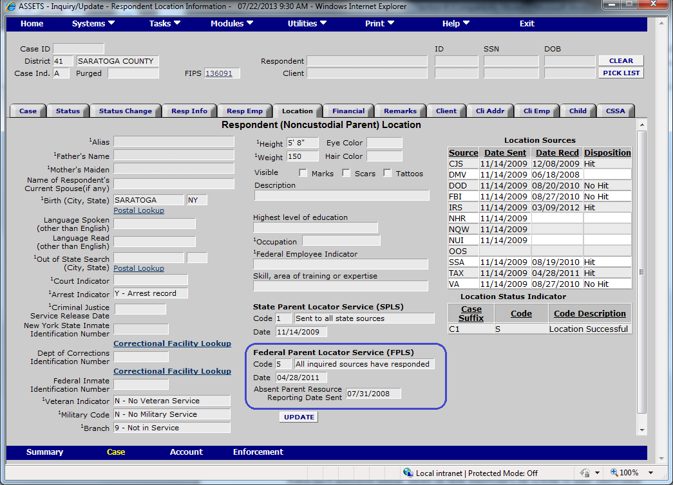

Screen Shot B-1-a-1-ii: Parent Locator Service **Response B-1-a-1:**

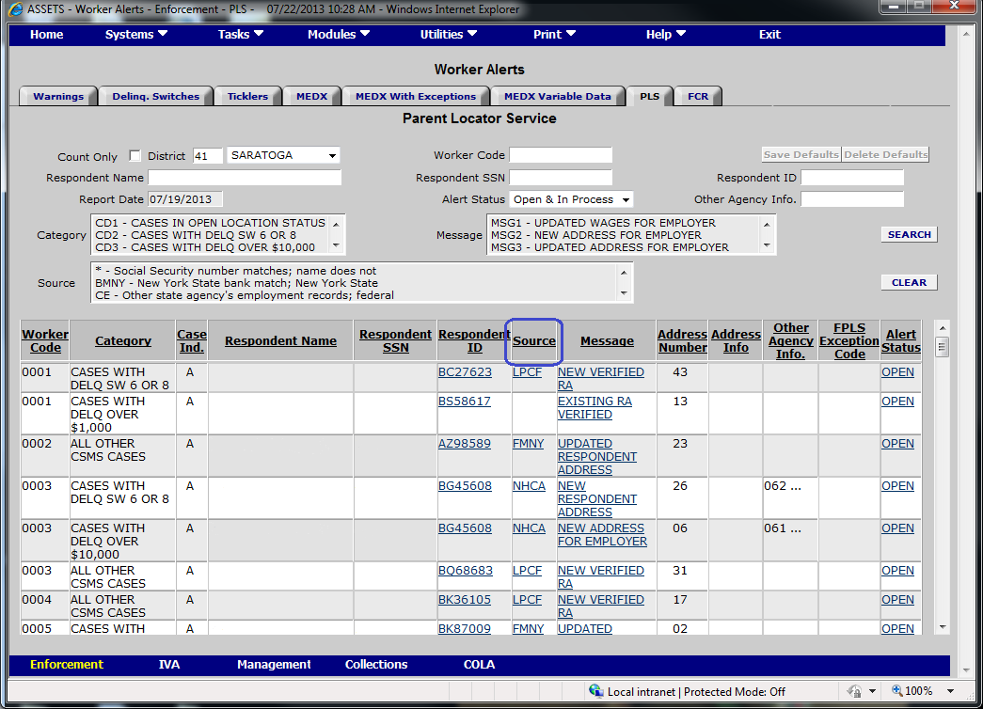

Screen Shot B-1-a-2-i: Respondent Location **Response B-1-a-2:**

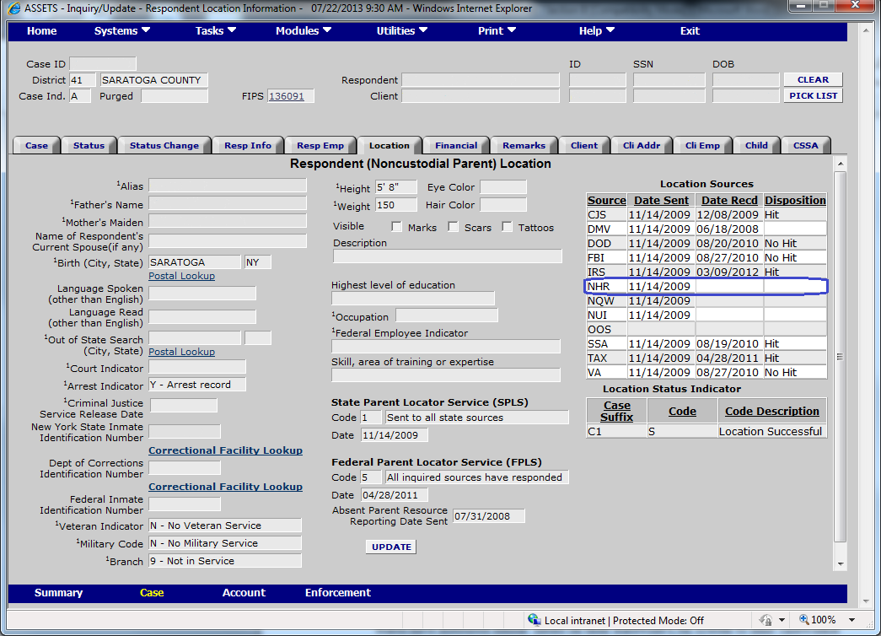

Screen Shot B-1-a-2-ii: Parent Locator Service **Response B-1-a-2:**

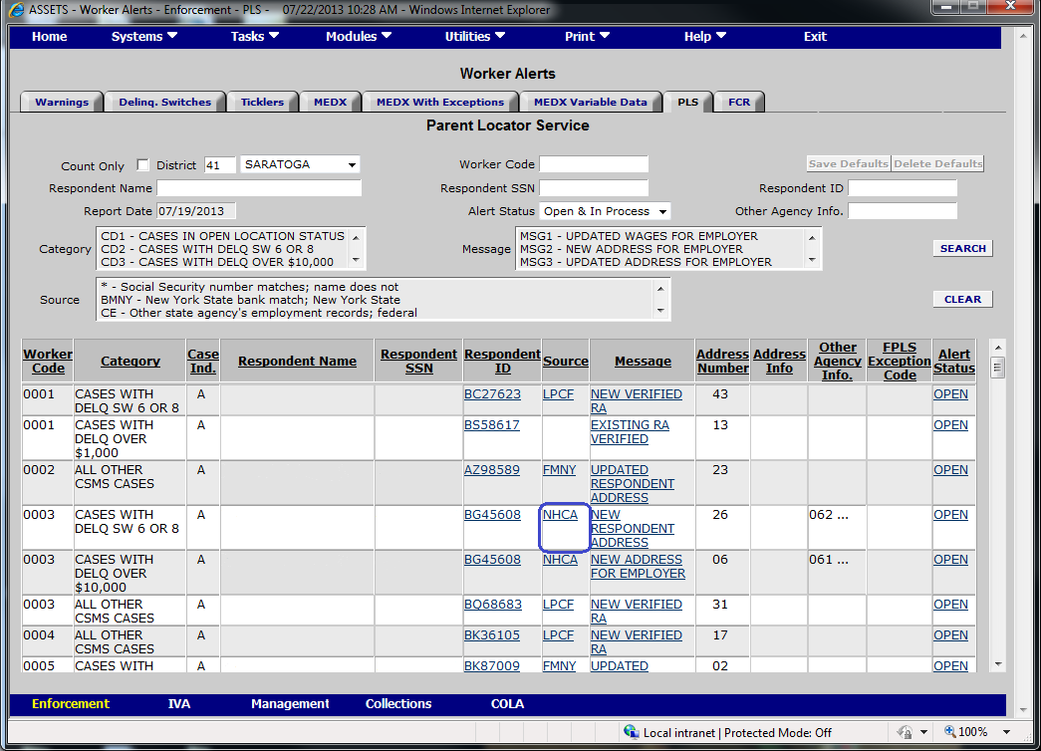

Screen Shot B-1-a-3-i: Case Information **Response B-1-a-3:**

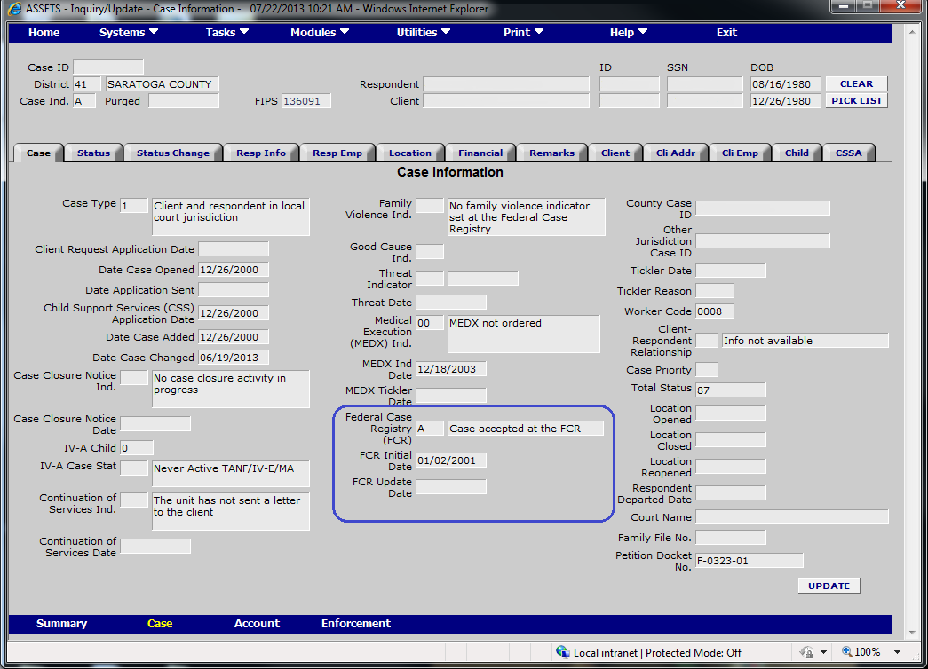

Screen Shot B-1-a-3-ii: Federal Case Registry **Response** **B-1-a-3:**

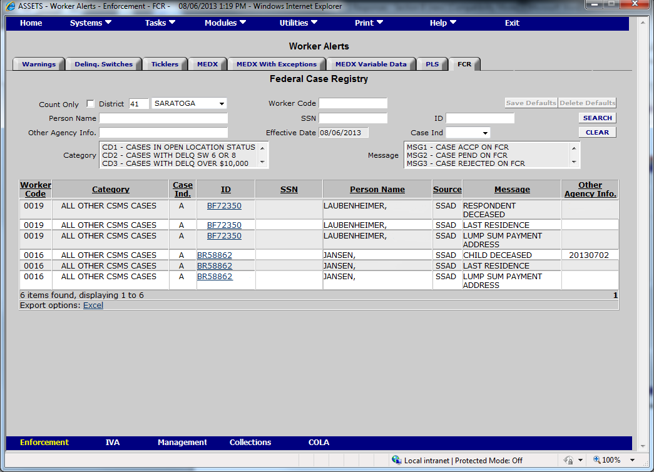

Screen Shot B-1-a-4-i: Respondent Location **Response B-1-a-4:**

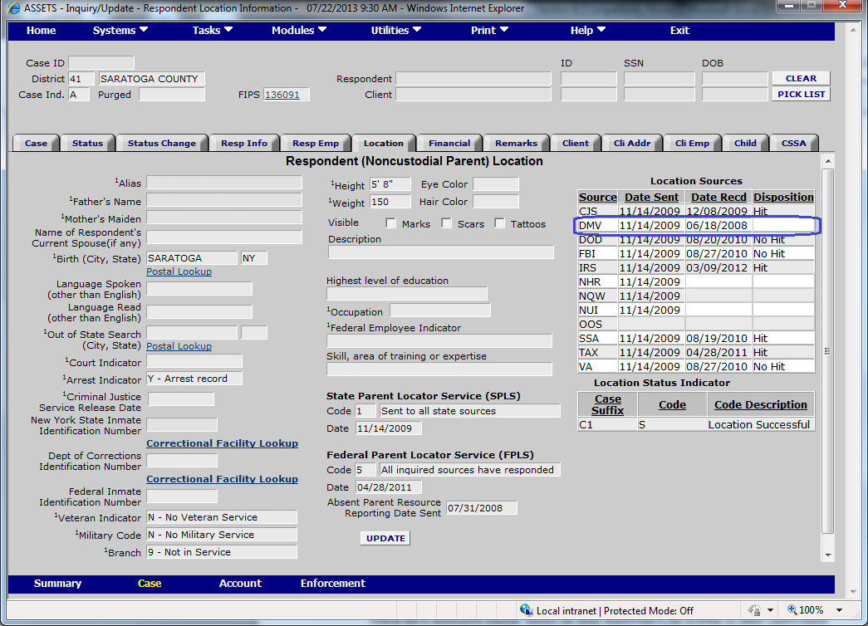

Screen Shot B-1-a-4-ii: Parent Locator Service **Response B-1-a-4:**

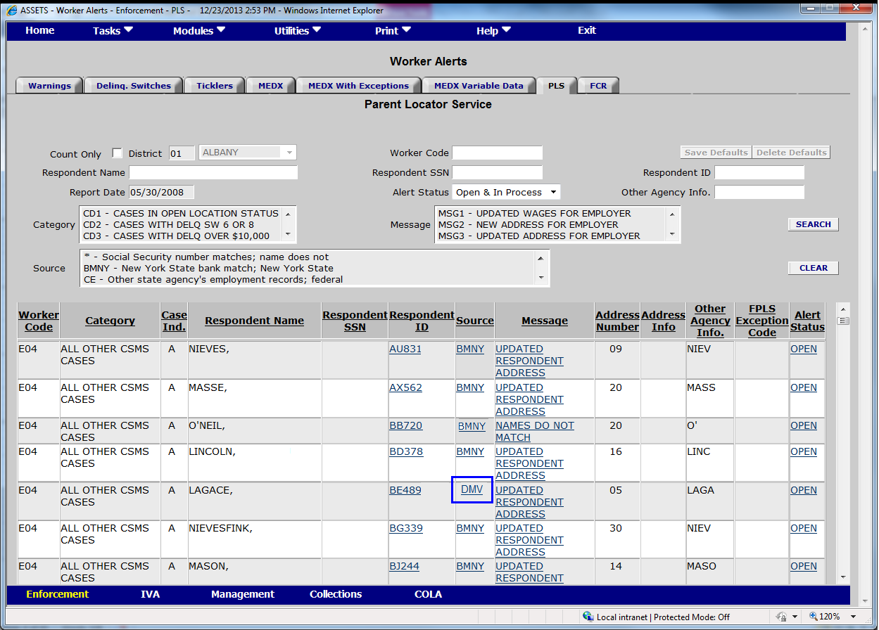

Screen Shot B-1-a-5-i: Respondent Information Response B-1-a-5:

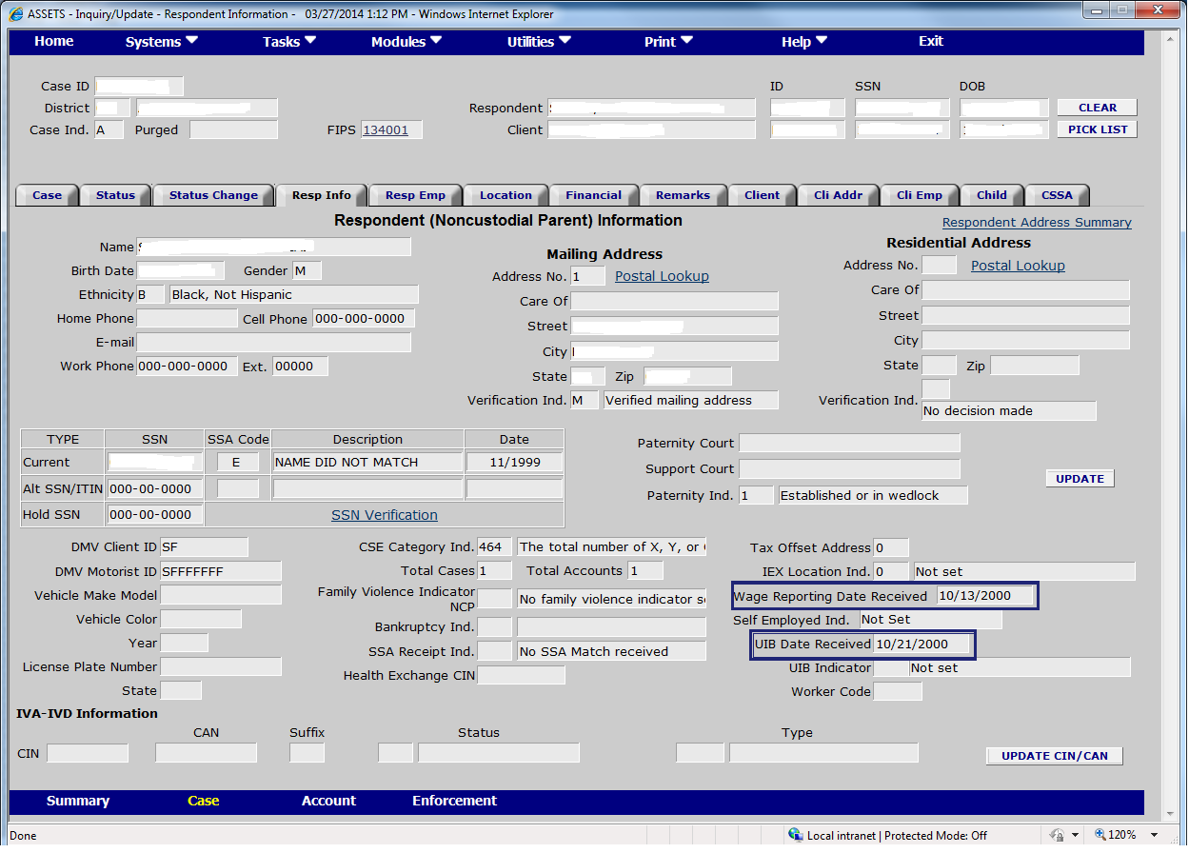

Screen Shot B-1-a-5-ii: Parent Locator Service **Response B-1-a-5:**



Screen Shot B-1-a-8-i: Respondent Location **Response B-1-a-8:**

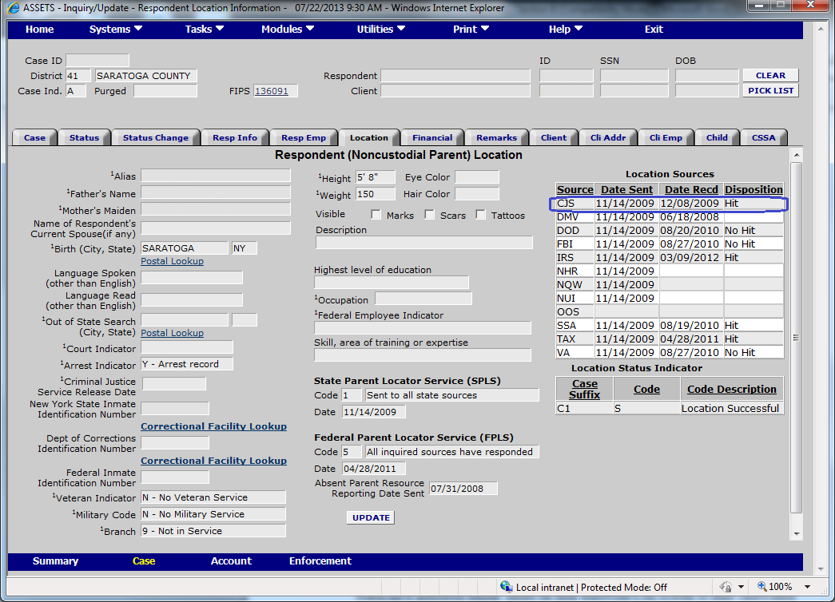

Screen Shot B-1-a-8-ii: Parent Locator Service **Response B-1-a-8:**

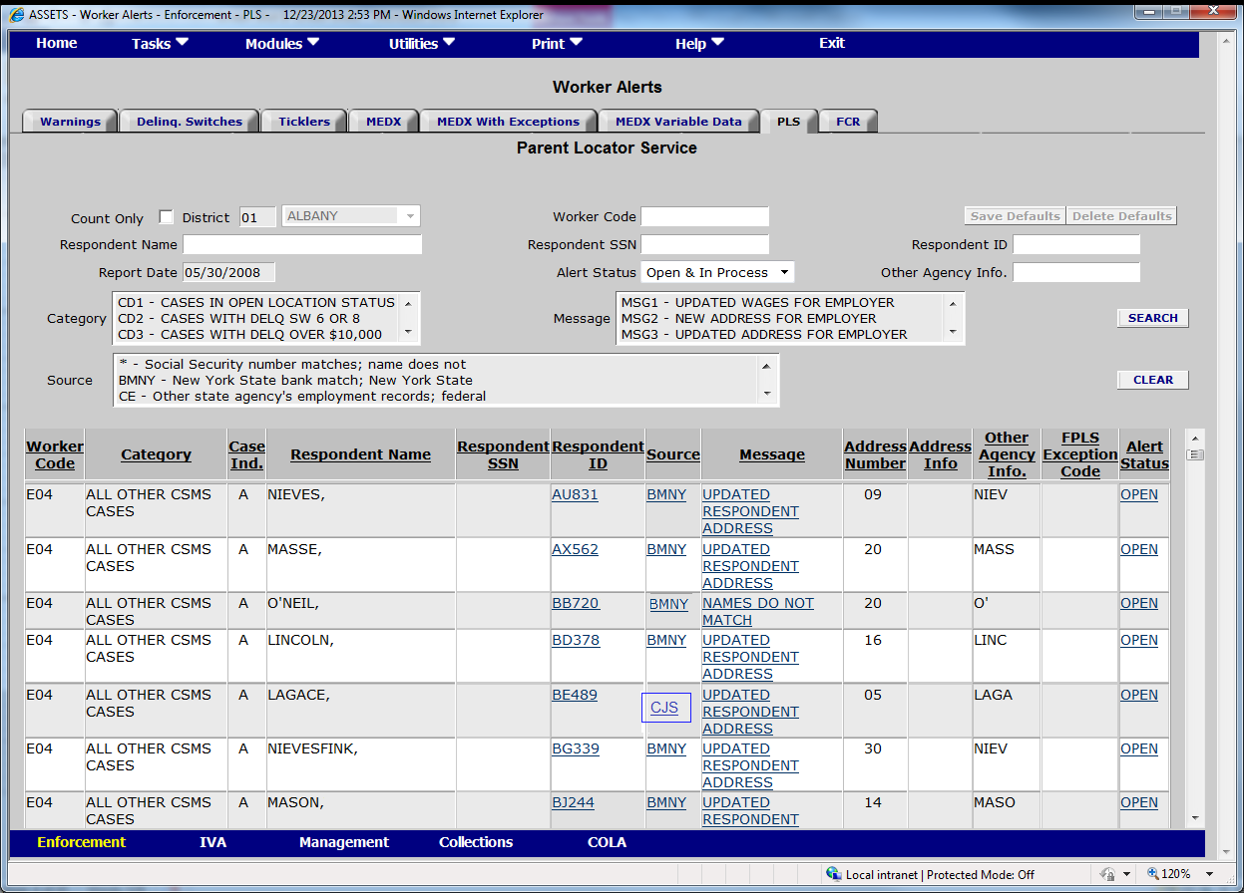

Screen Shot B-1-a-10-i: Status Information Response B-1-a-10:

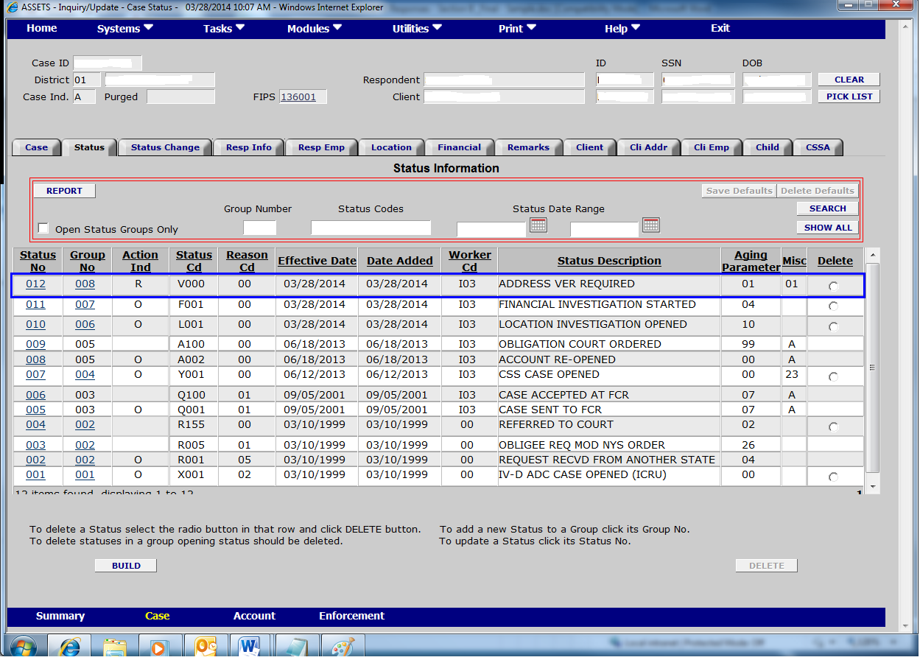

Screen Shot B-1-a-10-ii: Respondent Address **Response B-1-a-10:**

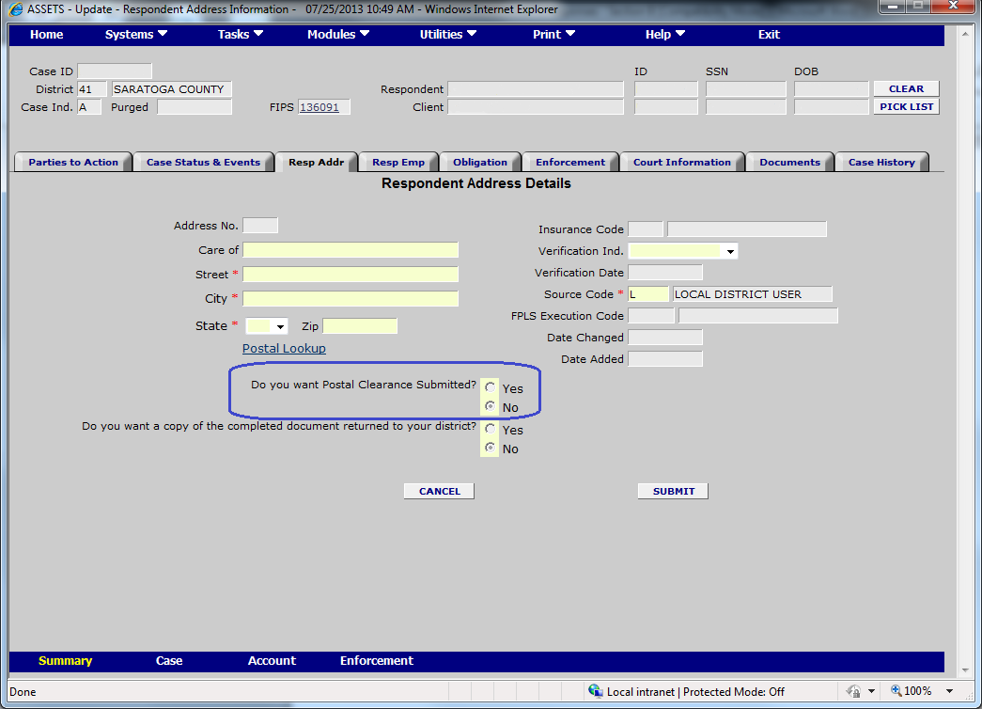

Screen Shot B-1-a-11-i: Respondent Location **Response B-1-a-11:**

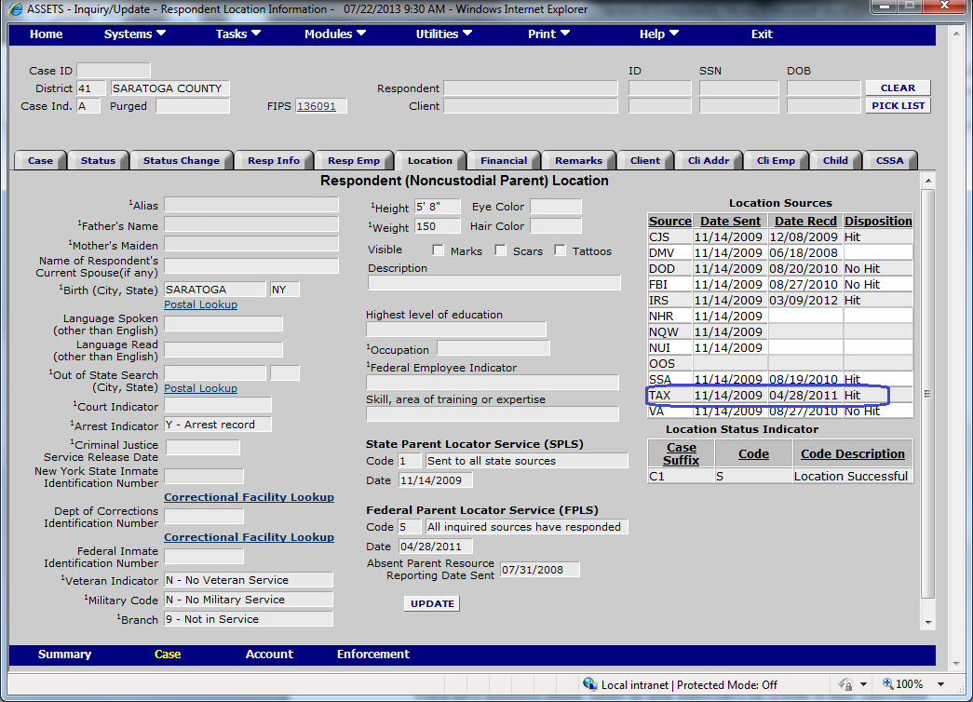

Screen Shot B-1-a-11-ii: Parent Locator Service **Response B-1-a-11:**

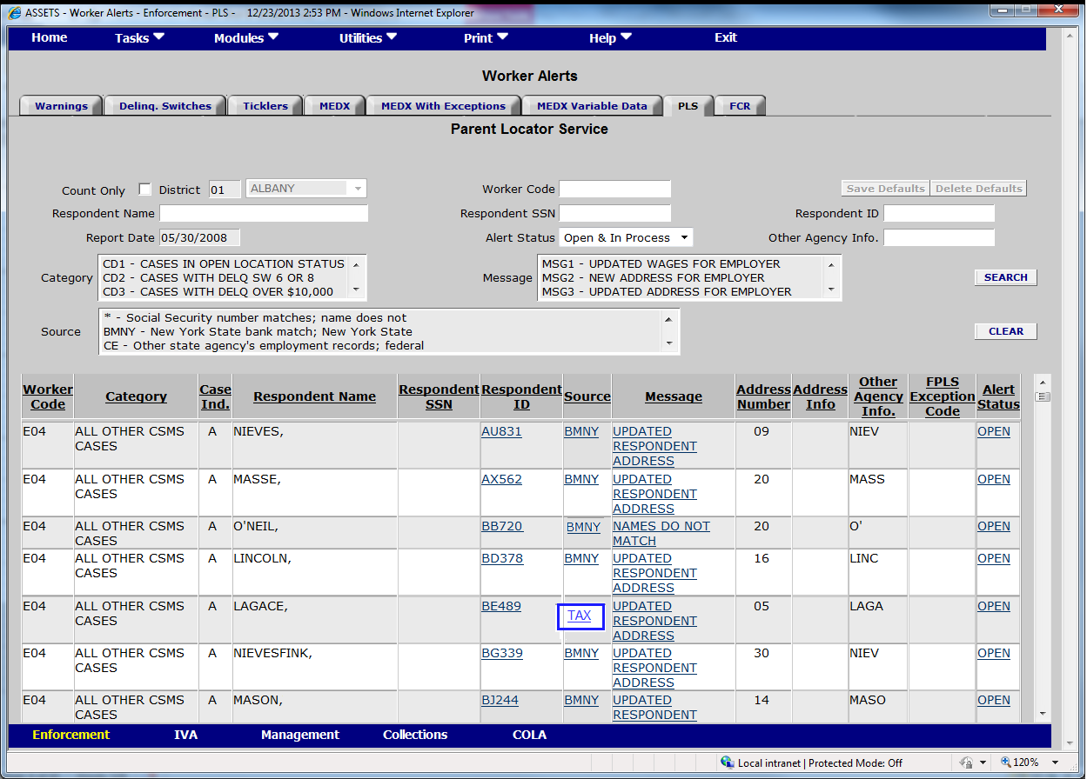

Screen Shot B-1-a-12: IVA-IVD Interface **Response B-1-a-12:**

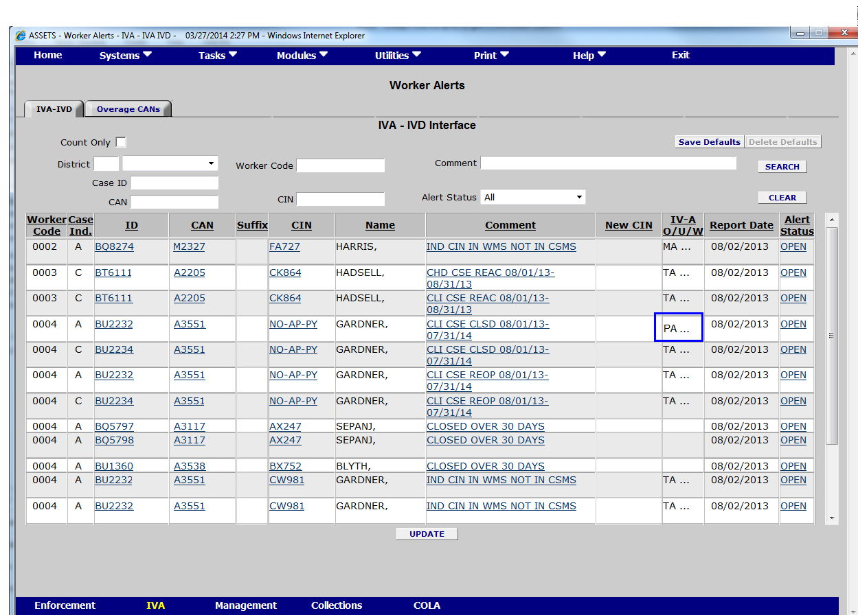

Screen Shot B-1-a-14: IVA-IVD Interface (MA) **Response B-1-a-14:**

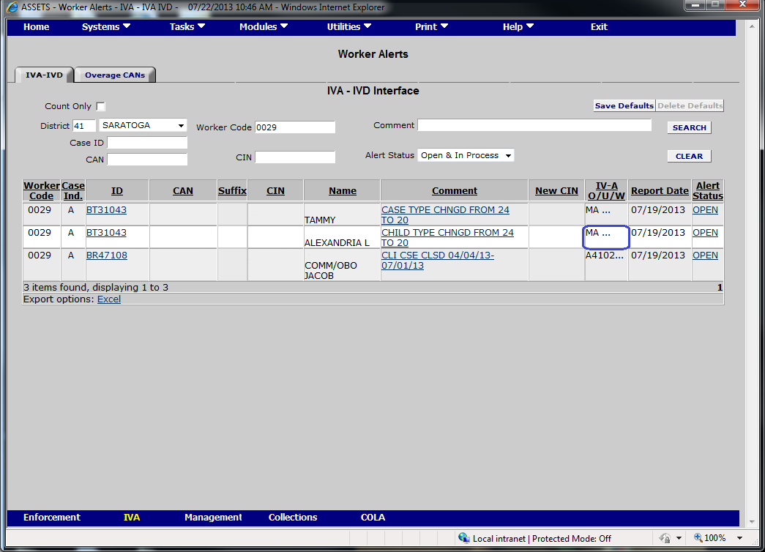

Screen Shot B-1-a-15: Parent Locator Service **Response B-1-a-15:**

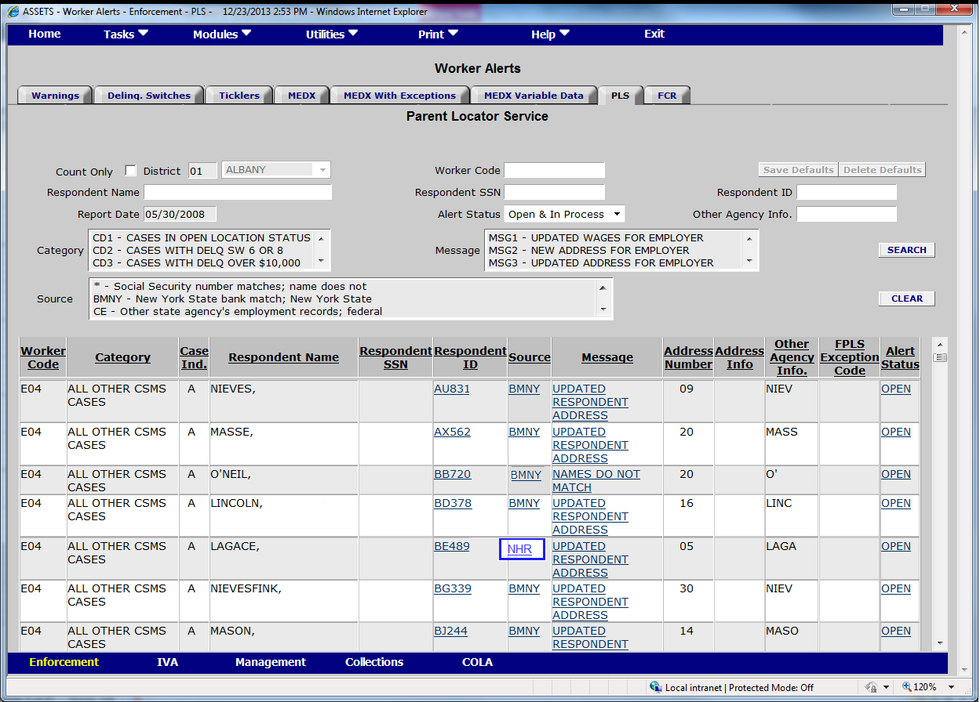

Screen Shot B-1-a-16: Money Transactions **Response B-1-a-16:**

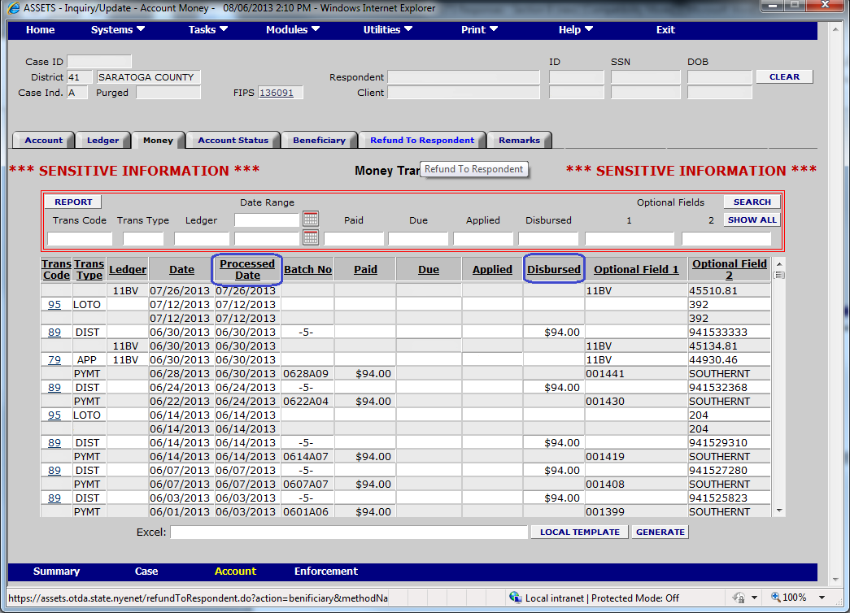

Screen Shot B-1-a-17: Administrative Subpoena Response B-1-a-17:

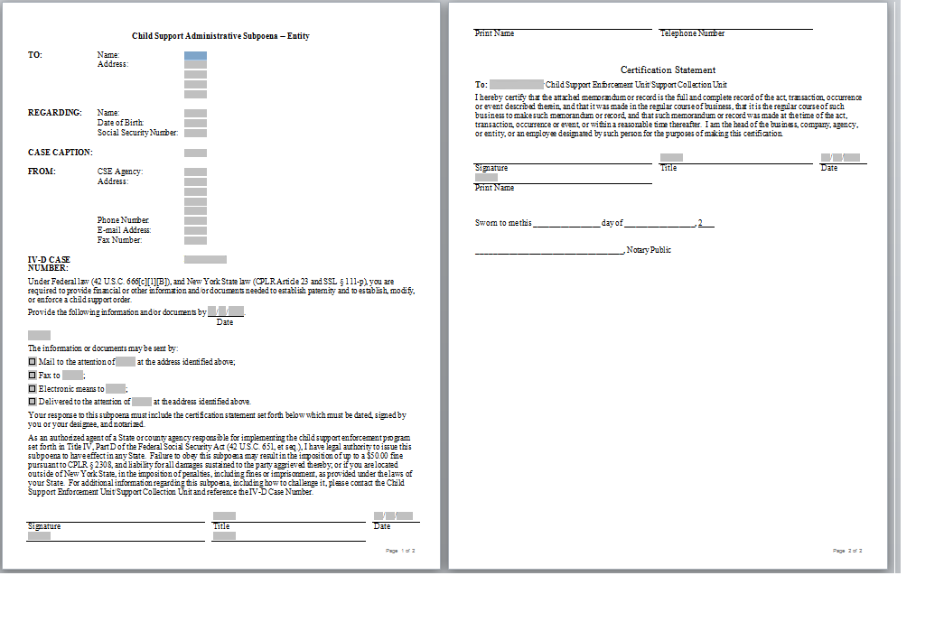

Screen Shot B-1-a-18-i: Worker Alerts **Response B-1-a-18:**

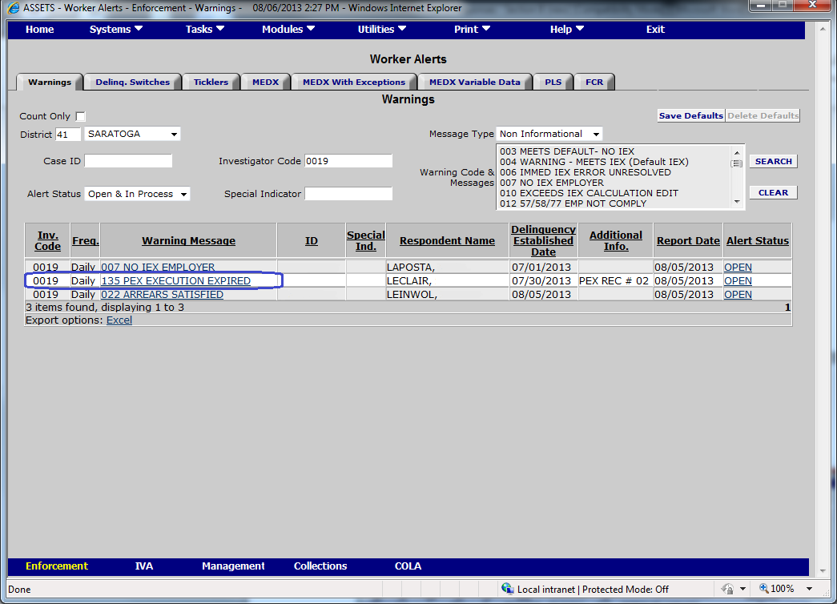

Screen Shot B-1-a-18-ii: Respondent Assets Information **Response B-1-a-18:**

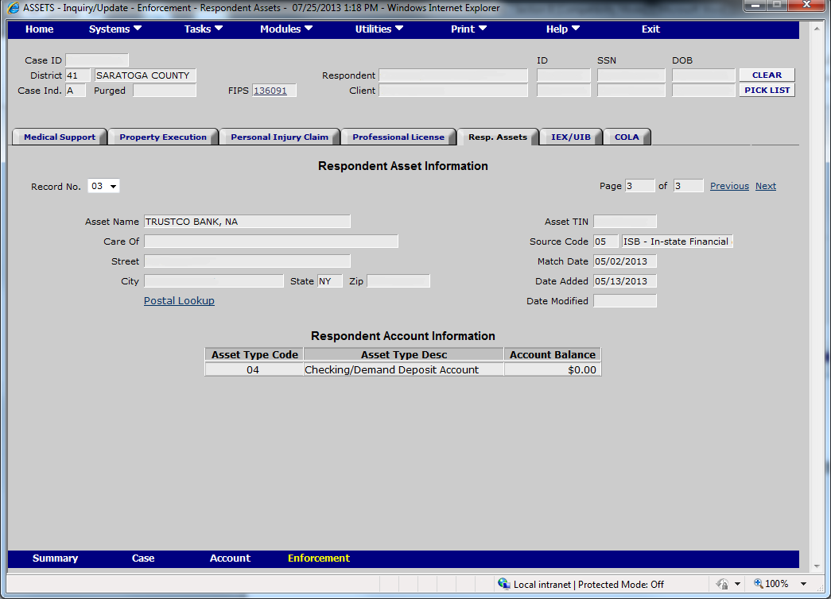

Screen Shot B-1-a-19: Professional License **Response B-1-a-19:**

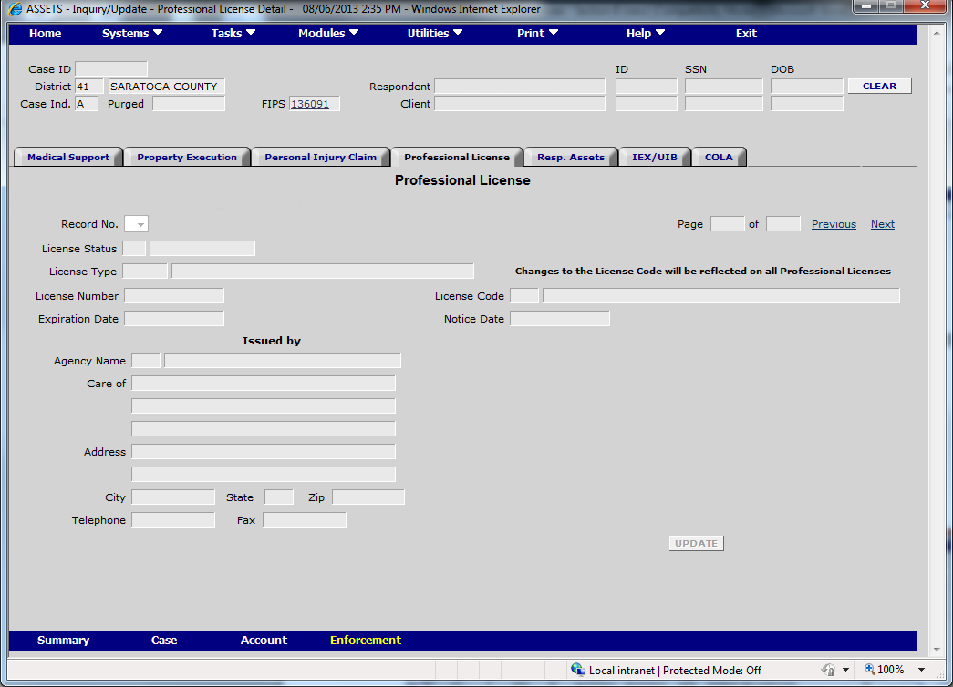

Screen Shot B-1-a-20: NYS Tax and Finance Enforcement **Response B-1-a-20:**

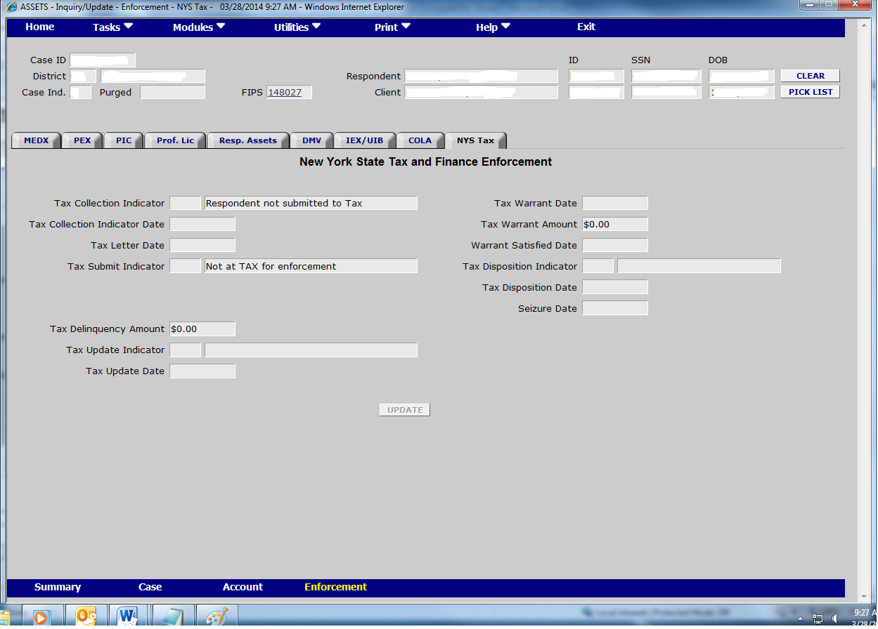

Screen Shot B-1-b-1-i: Status Information Response B-1-b-1:

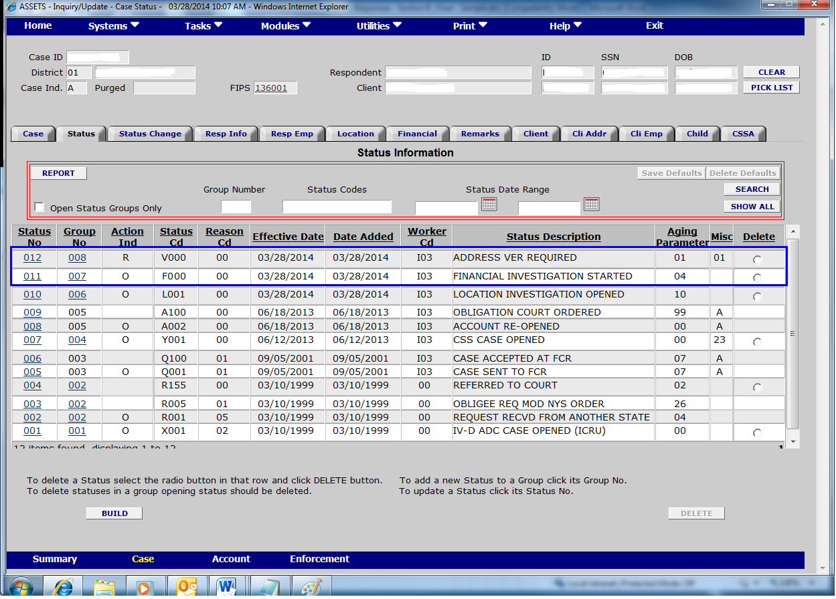

Screen Shot B-1-b-1-ii: Respondent Address **Response B-1-b-1:**



Screen Shot B-1-b-1-iii: Respondent Employer **Response B-1-b-1:**

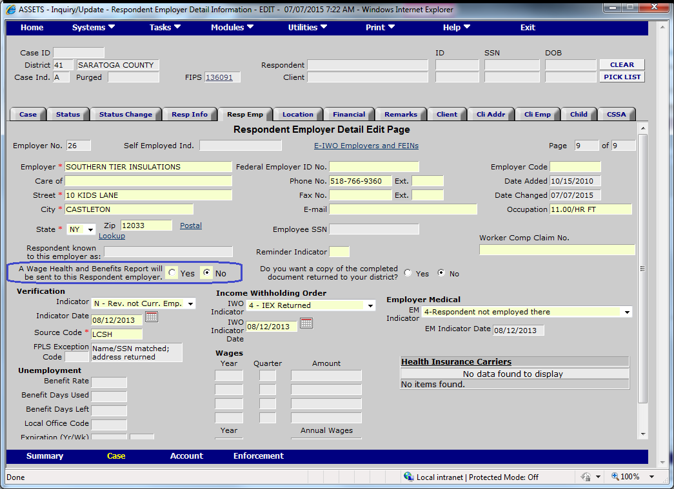

Screen Shot B-1-b-2-i: Status Information **Response B-1-b-2:**

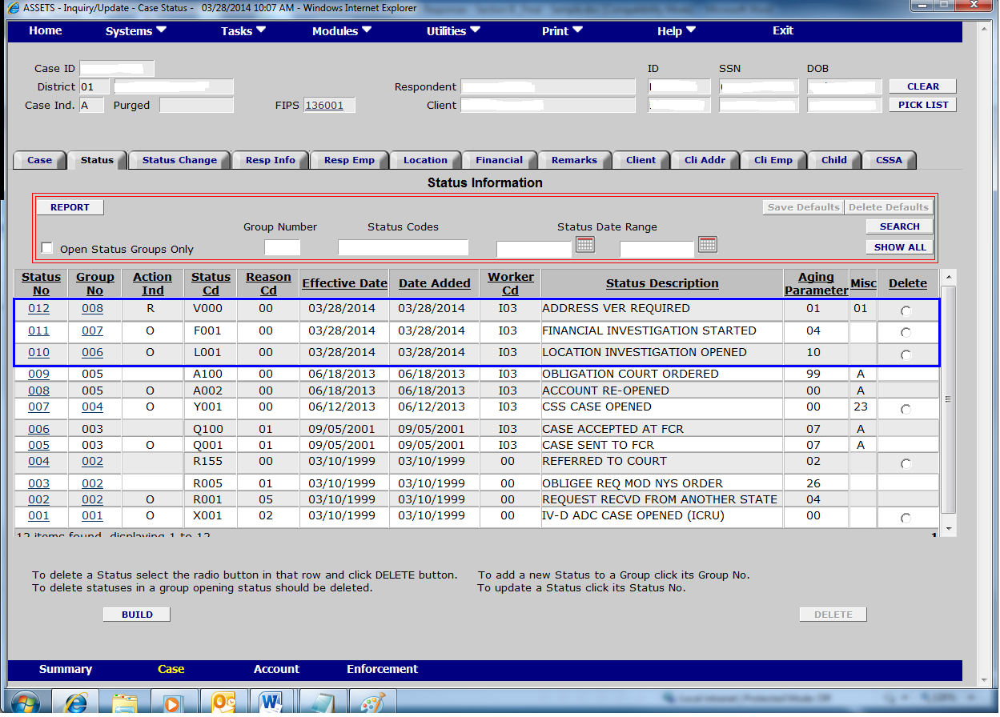

Screen Shot B-1-b-2-ii: Daily Status Changes **Response B-1-b-2:**

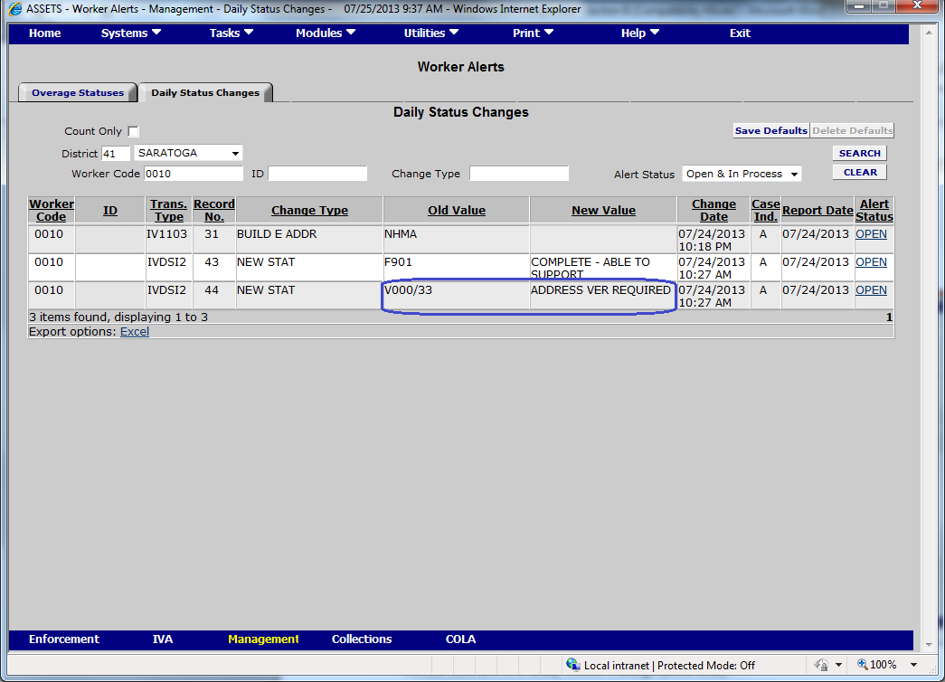

Screen Shot B-1-c-1: Status Information **Response B-****1-c-1****:**

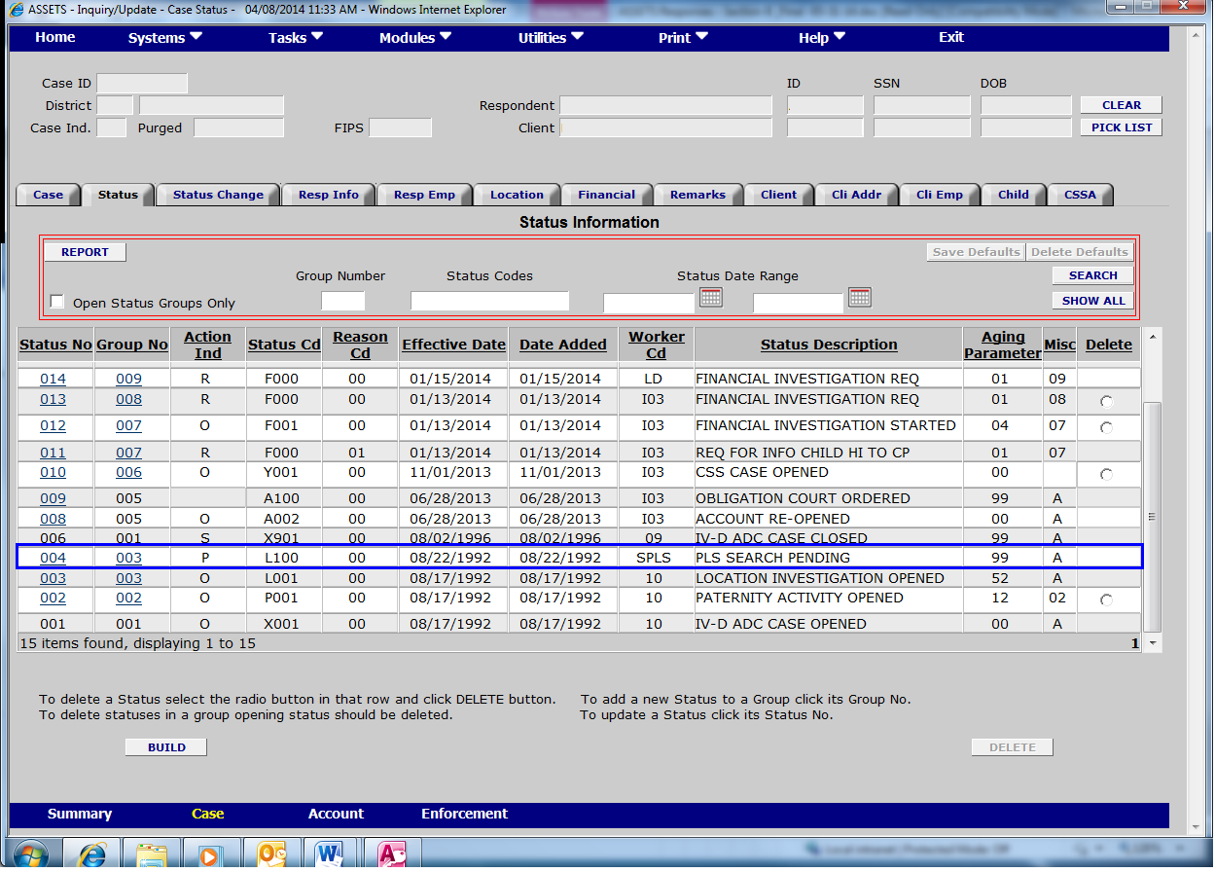

Screen Shot B-1-c-2-i: Parent Locator Service **Response B-1-c-2:**

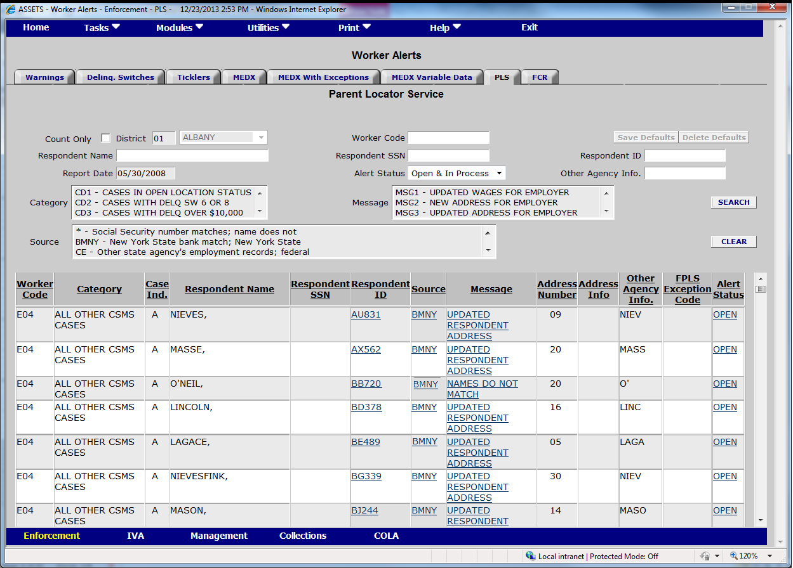

Screen Shot B-1-c-2-ii: Respondent Information **Response B-1-c-2:**

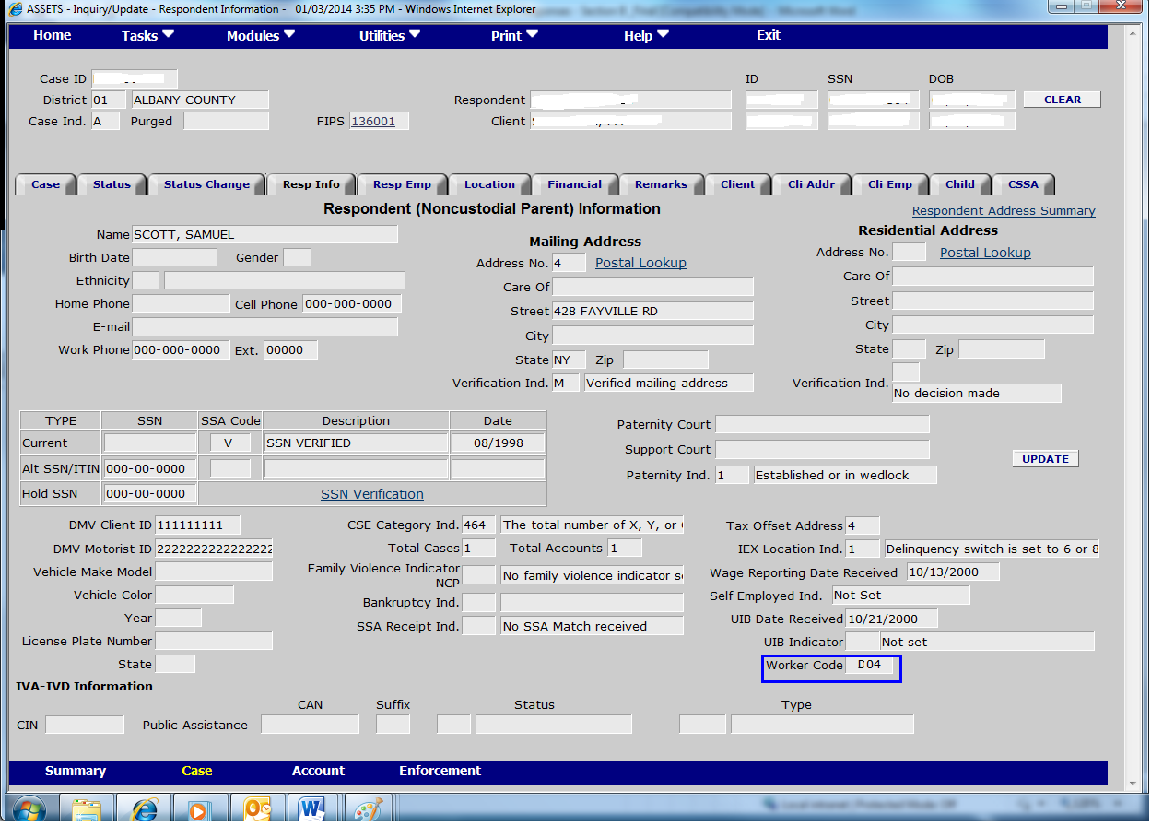

Screen Shot B-1-c-2-iii: Status Information **Response B-1-c-2:**



Screen Shot B-1-d-i: Respondent Location **Response B-1-d:**

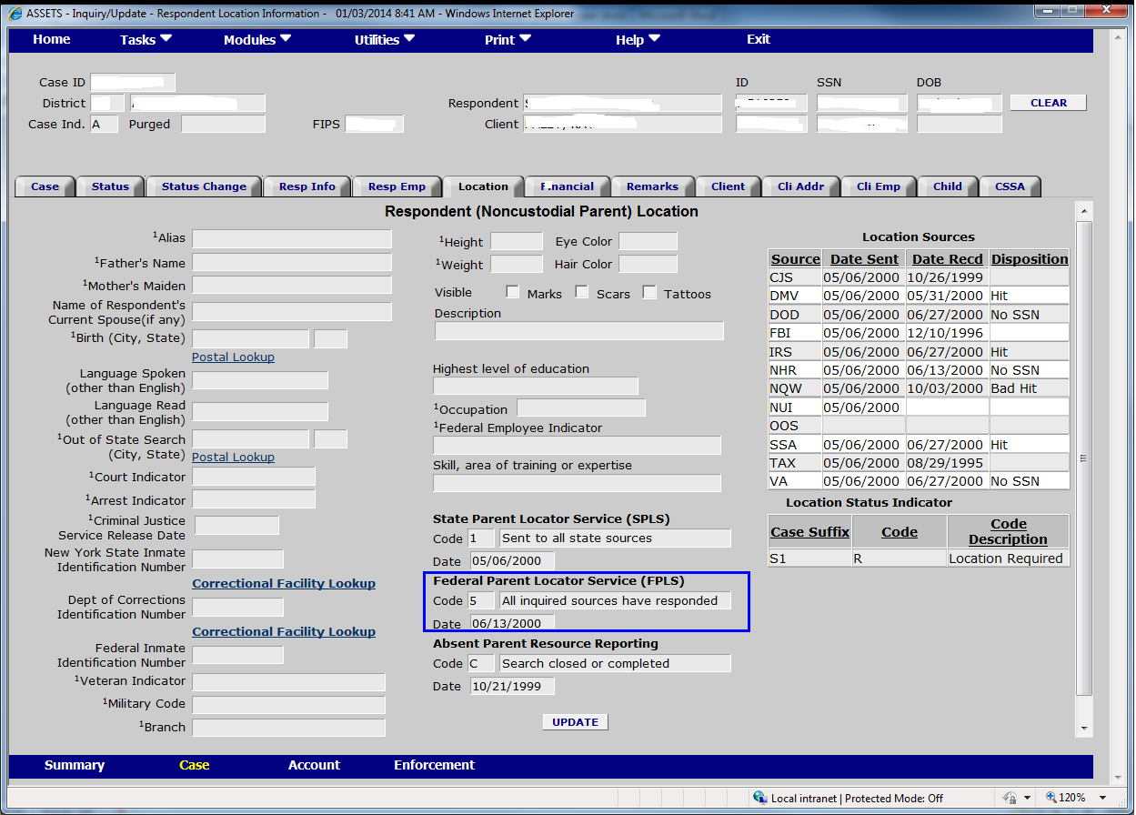

Screen Shot B-1-d-ii: Respondent Employer **Response B-1-d:**

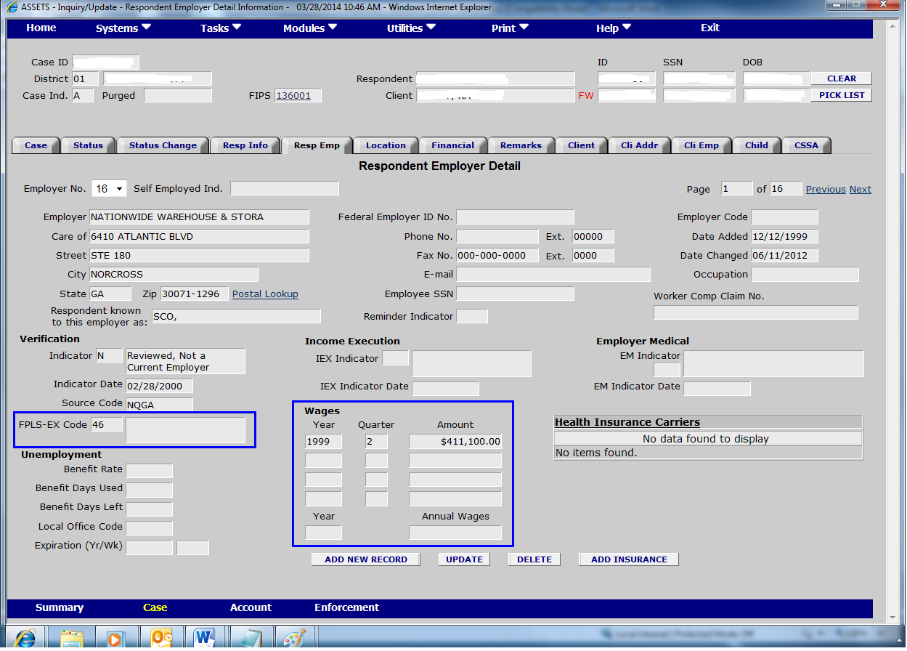

Screen Shot B-1-f: Status Information **Respo****nse B-1-f:**

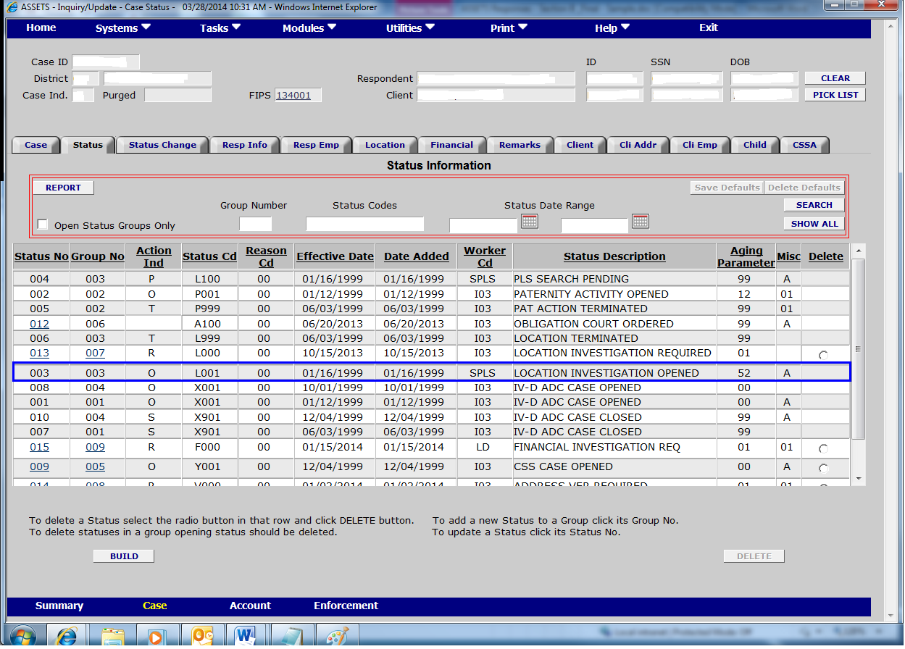

Screen Shot B-2-a-1-i: Status Information **Resp****onse B-2-a-1:**



Screen Shot B-2-a-1-ii: Child Support Application/Case Build **Response B-2-a-1:**

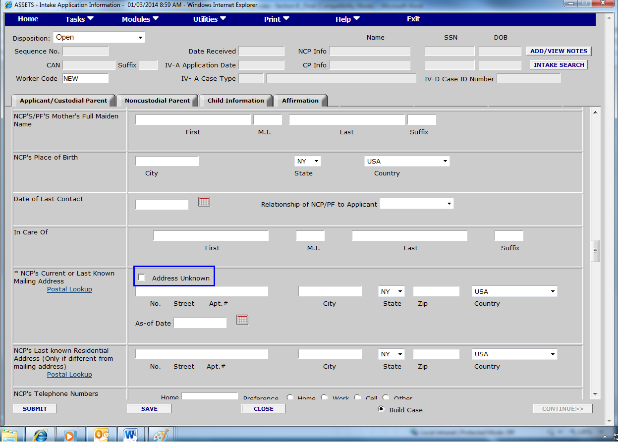

Screen Shot B-2-a-2-i: Respondent Addresses **Response B-2-a-2:**

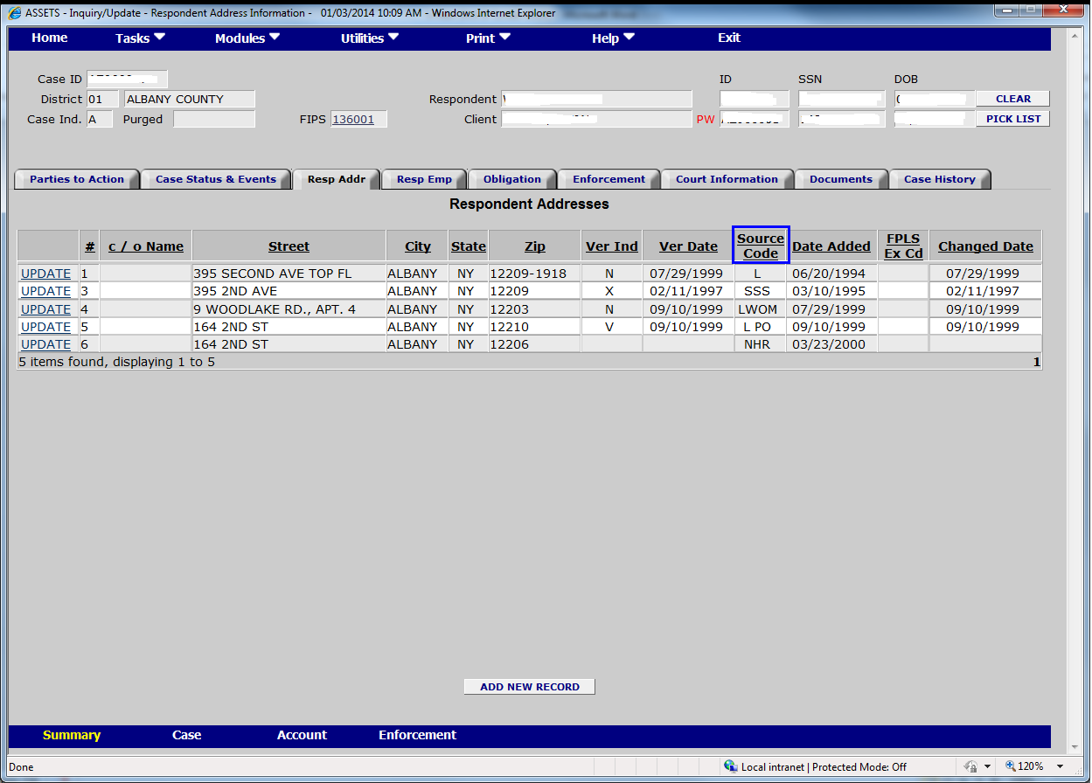

Screen Shot B-2-a-2-ii: Respondent Employer Summary **Response B-2-a-2:**

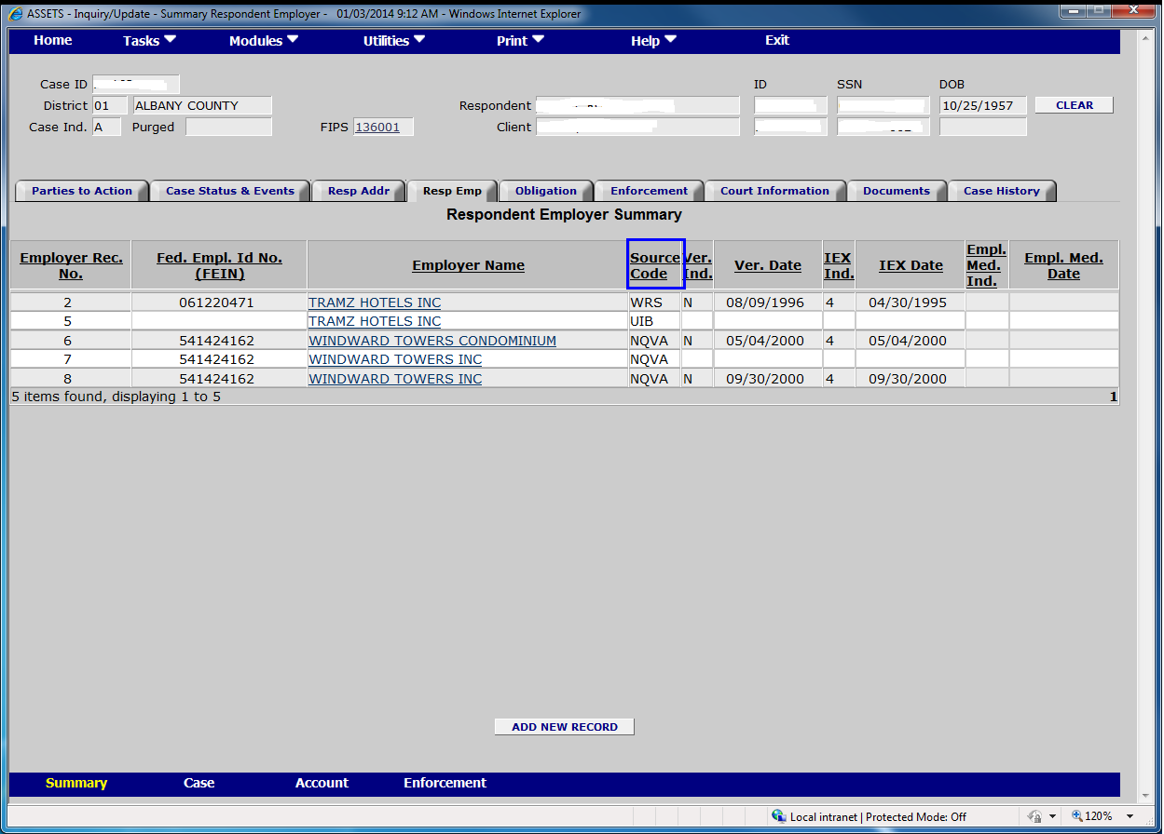

Screen Shot B-2-a-2-iii: Respondent Location **Response B-2-a-2:**

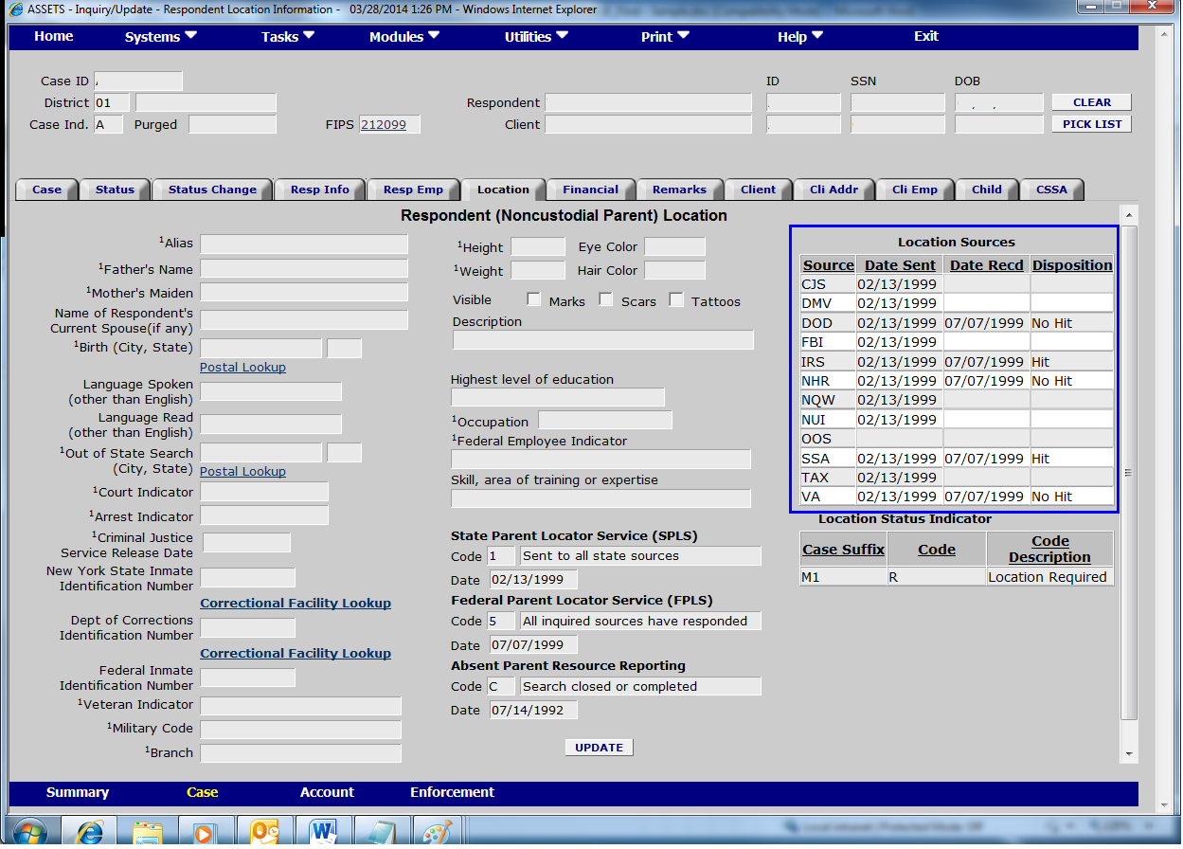

Screen Shot B-2-a-2-iv: Parent Locator Service **Response B-2-a-2:**



Screen Shot B-2-a-2-v: Status Information **Response B-2-a-2:**

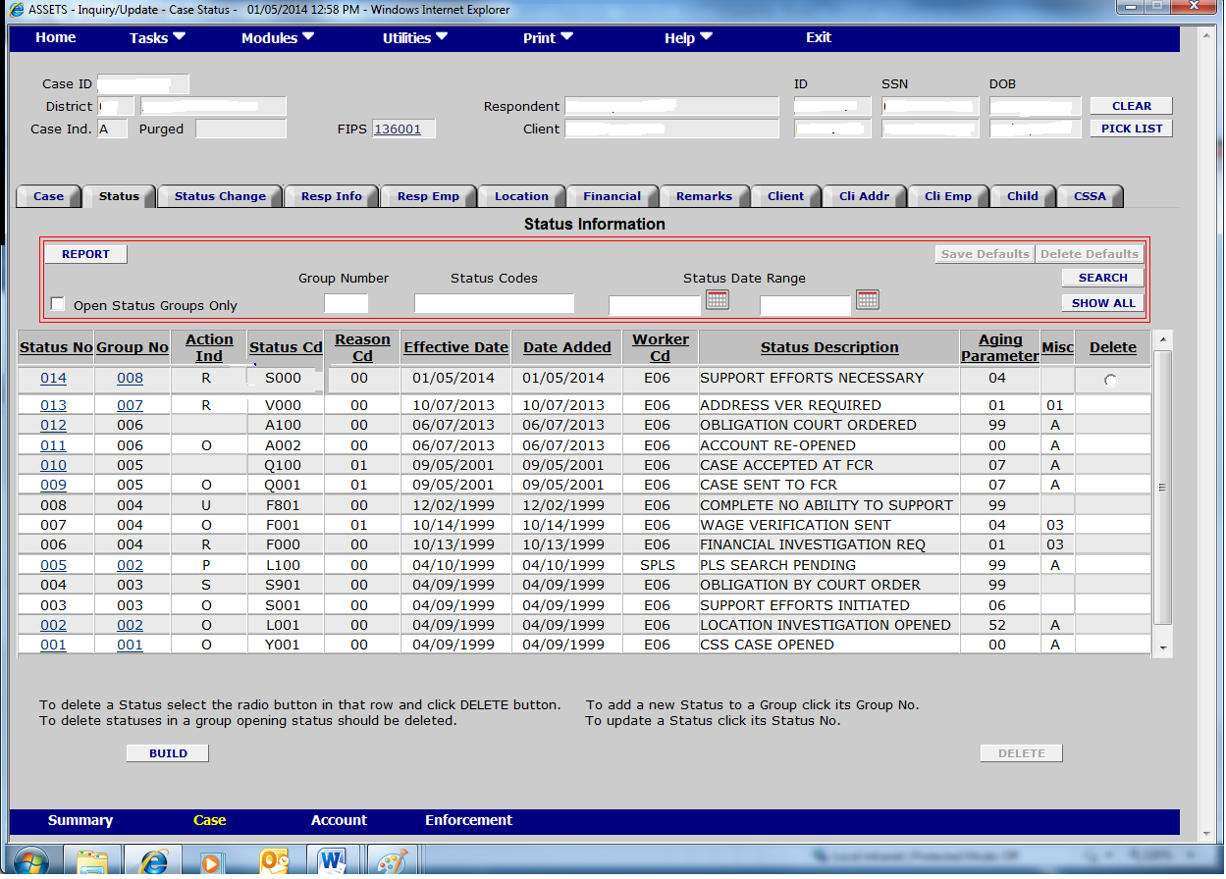

Screen Shot B-2-a-3-i: Respondent Information Response B-2-a-3:

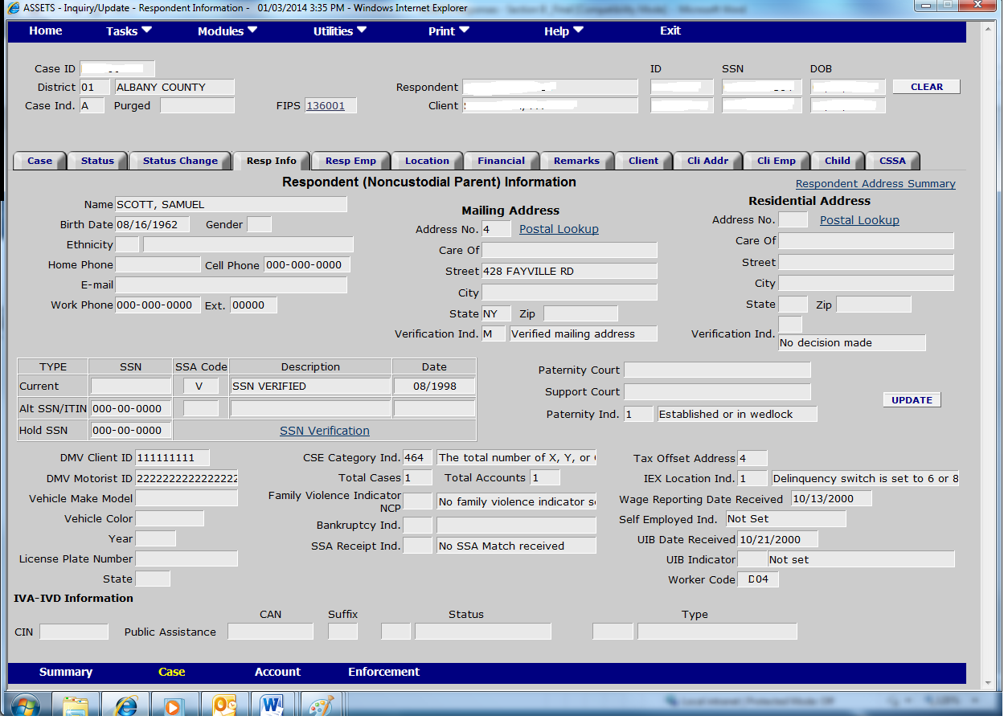

Screen Shot B-2-a-3-ii: Respondent Address **Response B-2-a-3:**

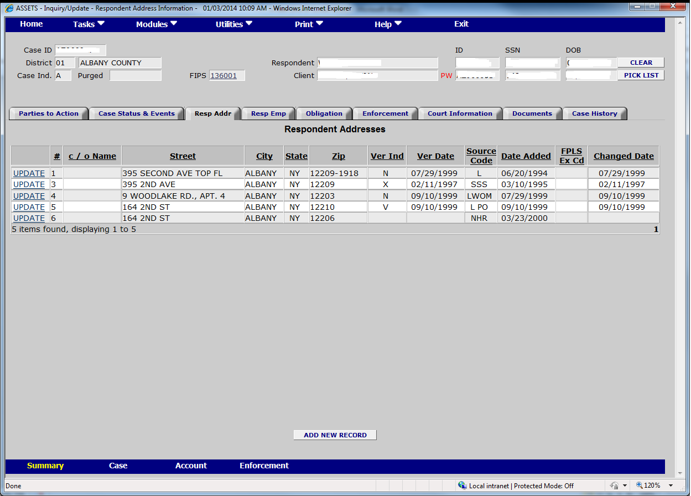

Screen Shot B-2-a-3-iii: Respondent Financial **Response B-2-a-3:**

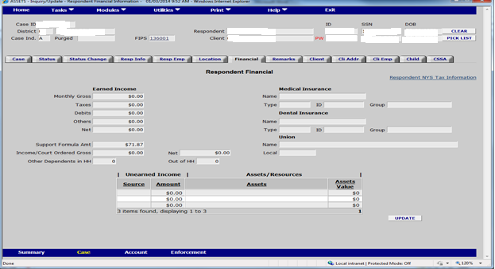

Screen Shot B-2-a-3-iv: Respondent Employer **Response B-2-a-3:**

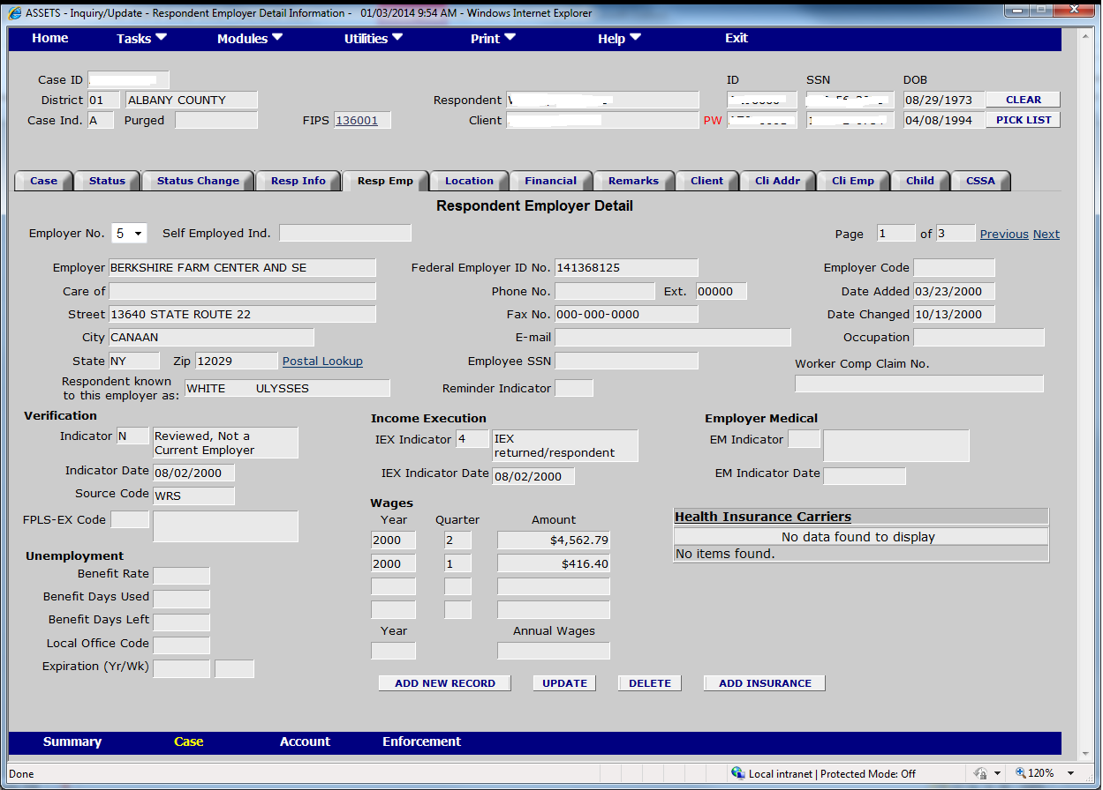

Screen Shot B-2-a-4-i: Respondent Address **Response B-2-a-4:**



Screen Shot B-2-a-4-ii: Respondent Employer **Response B-2-a-4:**



Screen Shot B-2-a-4-iii: Respondent Employer Summary **Response B-2-a-4:**

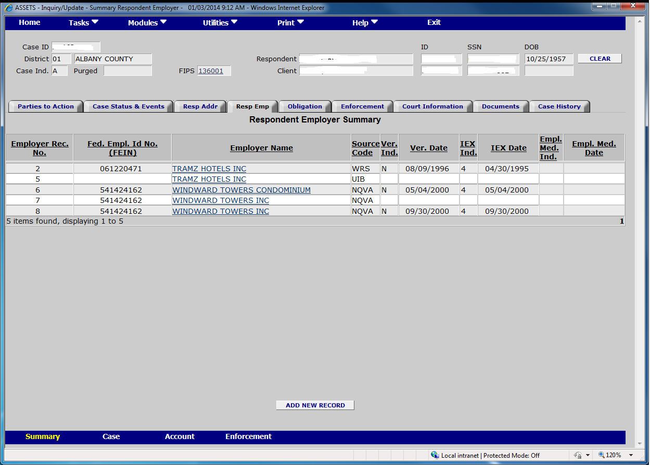

Screen Shot B-2-a-5-i: Respondent Addresses **Resp****onse B-2-a-5:**



Screen Shot B-2-a-5-ii: Respondent Employer Response B-2-a-5:



Screen Shot B-2-a-6-i: Parent Locator Service **Response B-2-a-6:**



Screen Shot B-2-a-6-ii: Respondent Information **Response B-2-a-6:**



Screen Shot B-2-a-7: Status Information screen **Response B-2-a-7:**

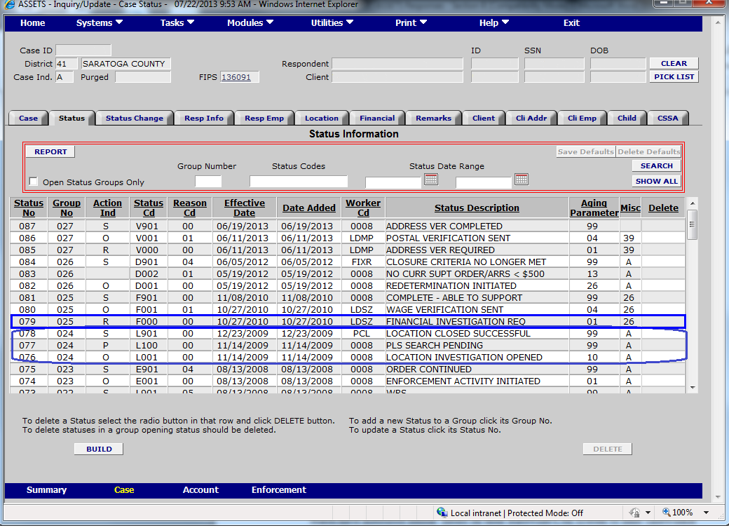

Screen Shot B-2-b-i: Status Information **Response B-2-b:**

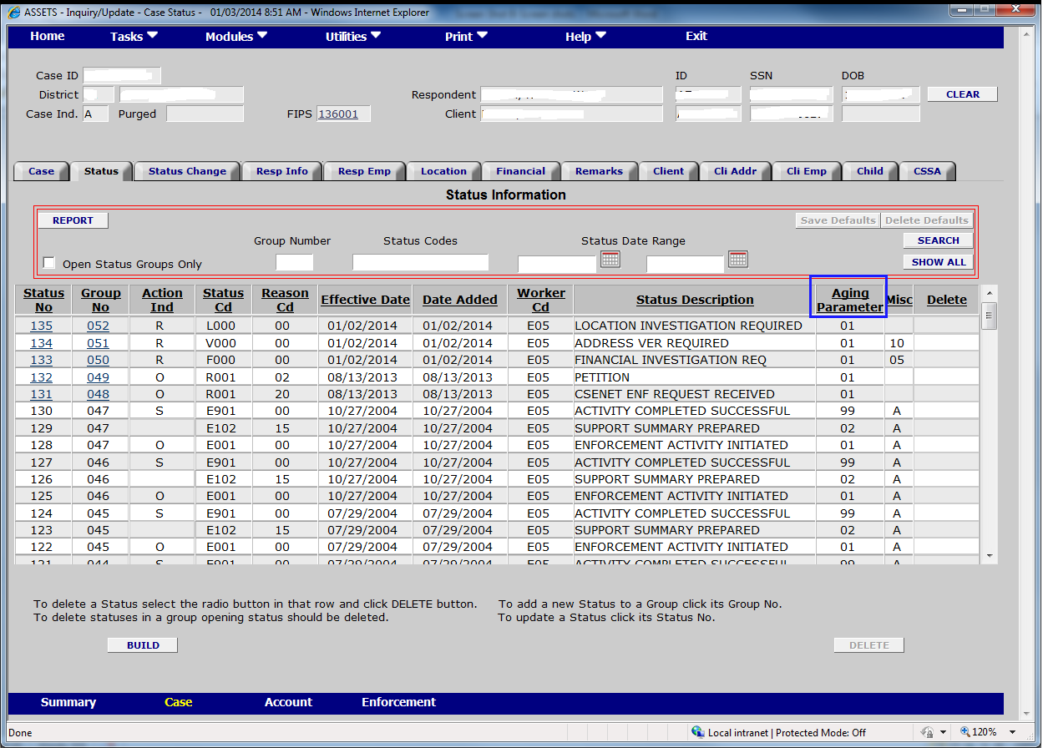

Screen Shot B-2-b-ii: Overage Statuses **Respon****se B-2-b:**

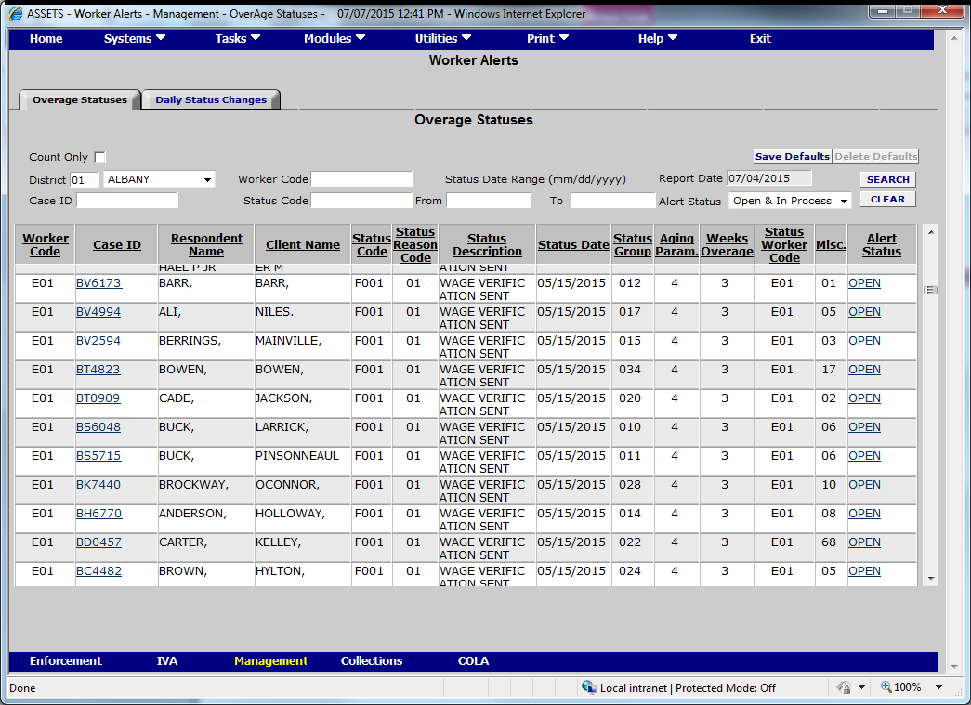

Screen Shot B-2-b-iii: Case Information **Response B-2-b:**

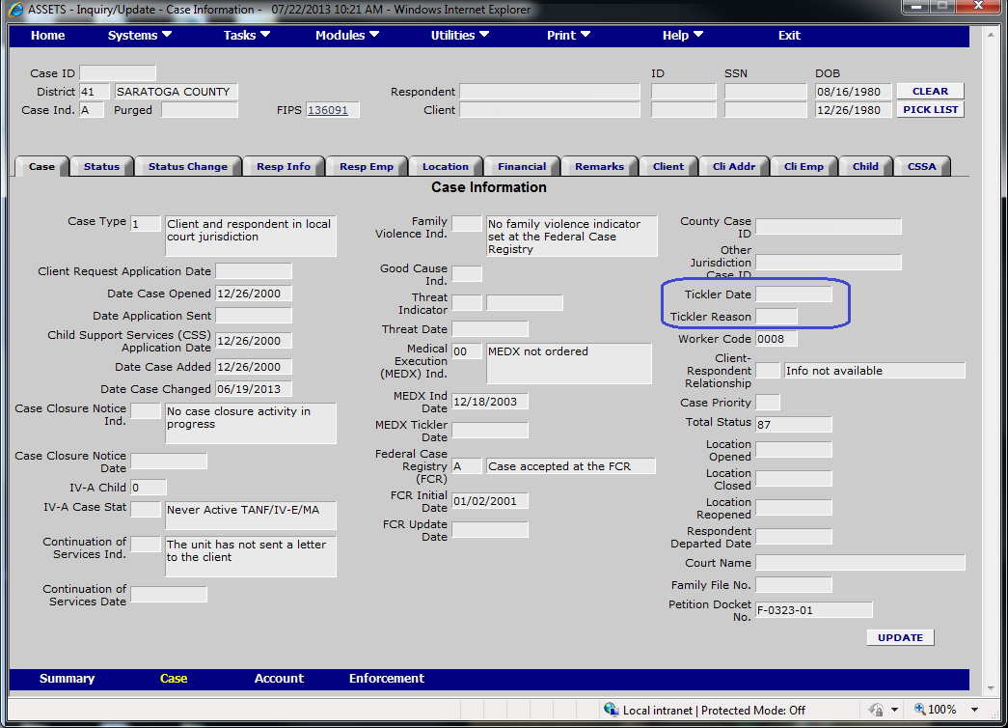

Screen Shot B-2-c-1-i: Overage Statuses **Response B-2-c-1:**



Screen Shot B-2-c-1-ii: Status Information **Response B-2-c-1:**

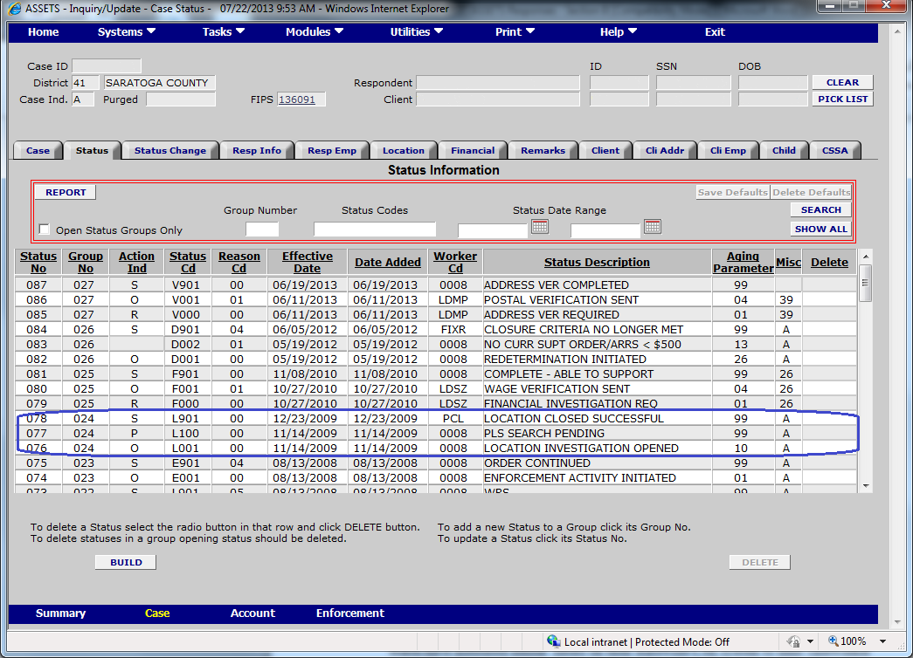

Screen Shot B-2-c-1-iii: Respondent Location **Response B-2-c-1:**

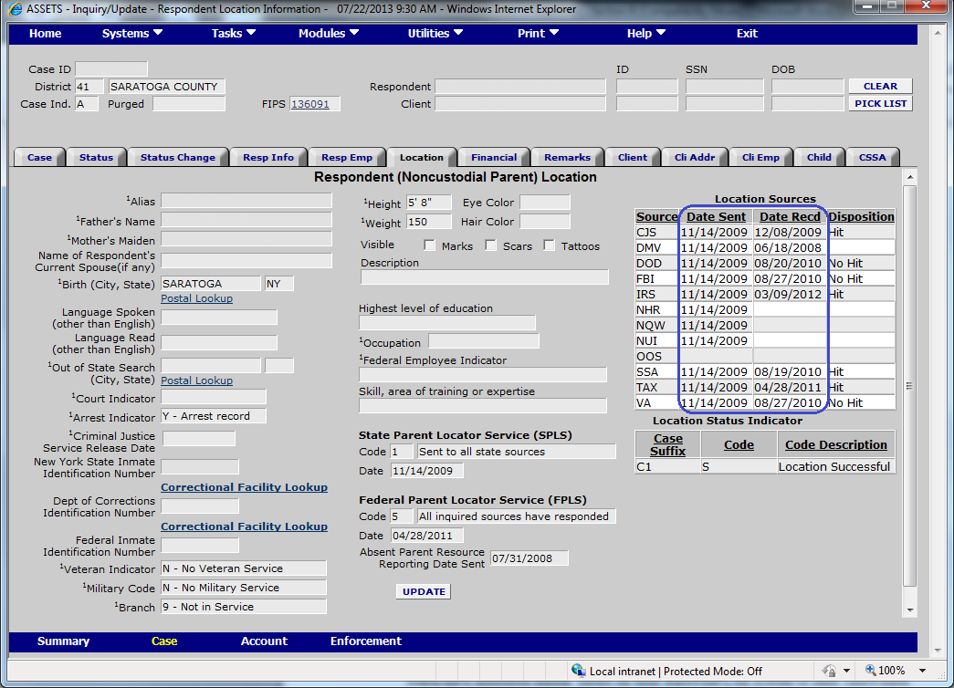

Screen Shot B-2-c-1-iv: Respondent Information **Response B-2-c-1:**



Screen Shot B-2-c-2-i: Parent Locator Service **Response B-2-c-2**



Screen Shot B-2-c-2-ii: Respondent Information **Response B-2-c-2**



Screen Shot B-2-c-2-iii: Status Information **Response** **B-2-c-2**



Screen Shot B-2-d: Respondent Location **Response B-2-d:**



Screen shot B-3-a: Respondent Information **Response B-3-a:**

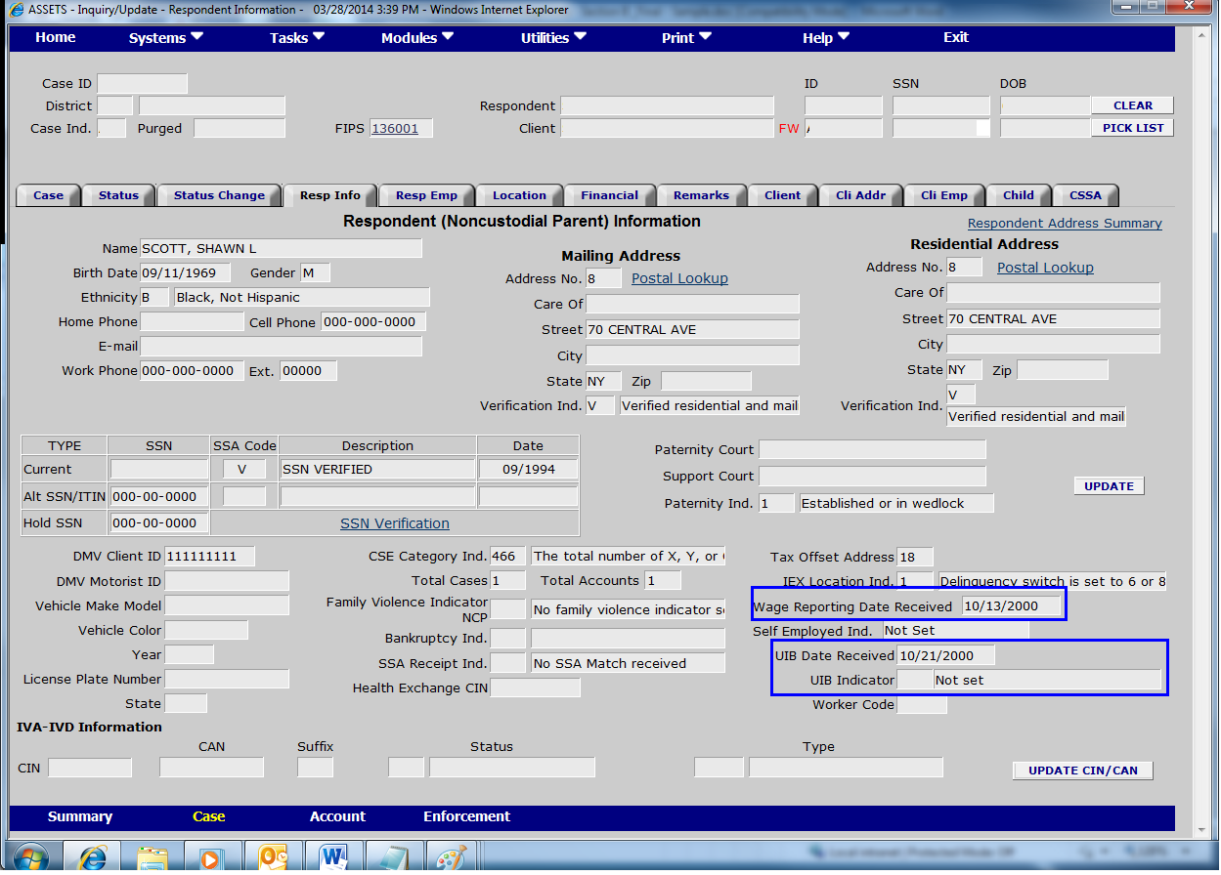

Screen Shot B-4-1 Case Information **Response B-4-1:**

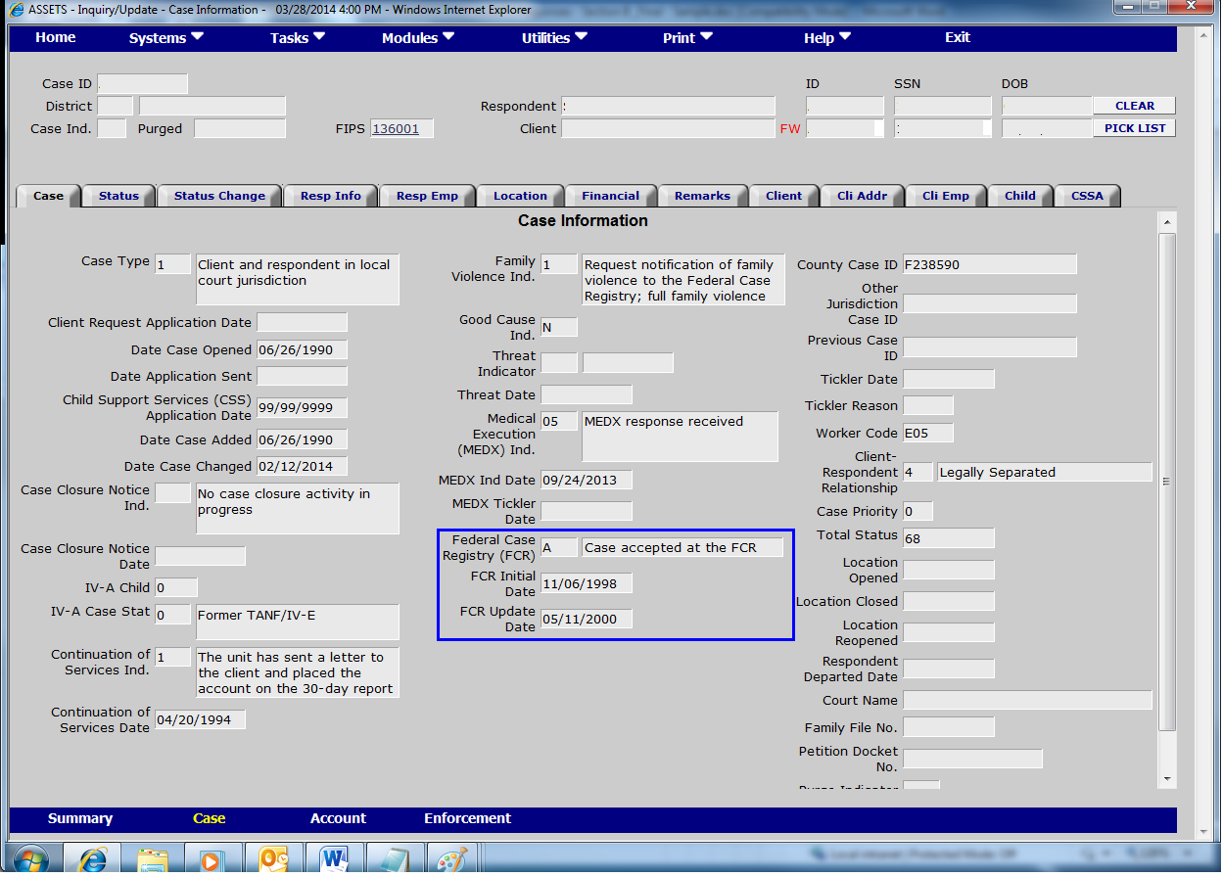

Screen Shot B-4-2: Status Information **Response B-4-2:**

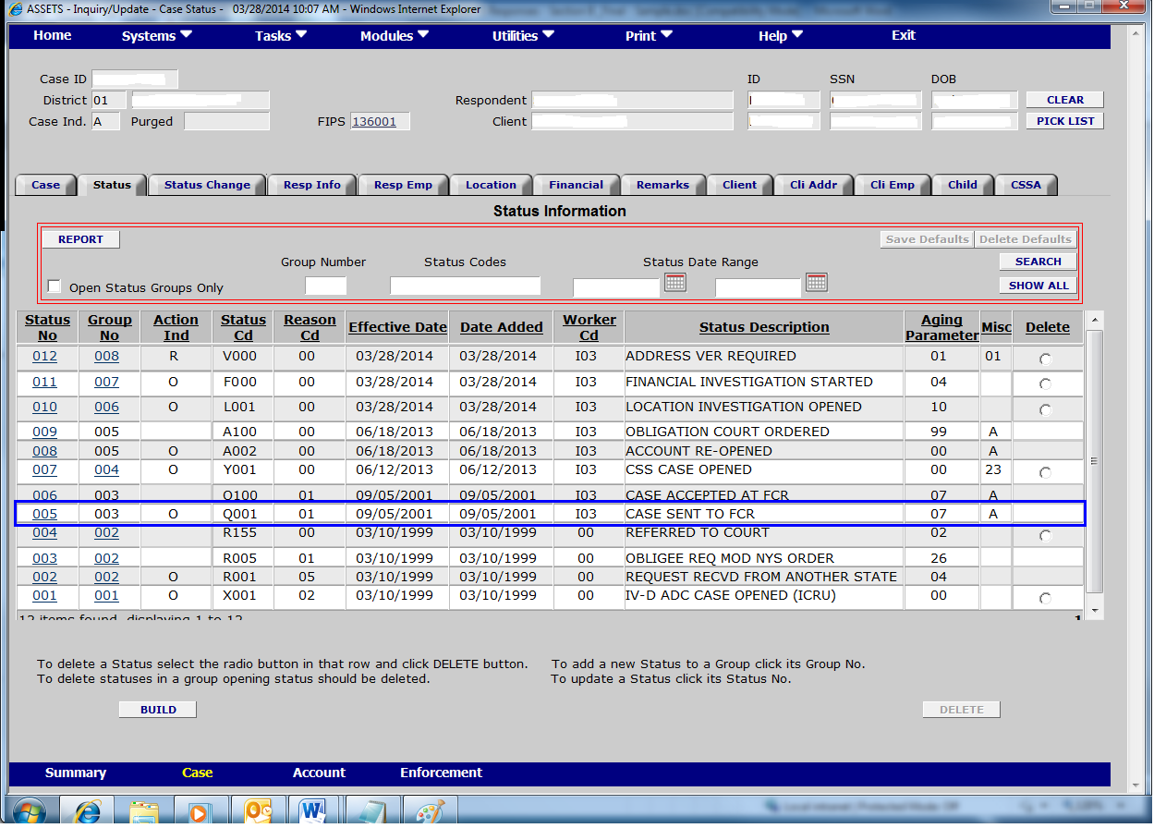

Screen Shot B-4-3-a: Respondent Location Response B-4-3-a:

